How to provide your COVID-19 Vaccination Evidence
In 2022 it is mandatory for all TasTAFE students to be fully vaccinated unless they are medically exempt. This is to help keep the TasTAFE community safe, along with yourself, your family, your friends and all Tasmanians.

What evidence is needed?
Your COVID-19 Digital Certificate or Immunisation History Statement will be needed to confirm you are fully vaccinated or medically exempt. You can access these via the Check In TAS app or the Medicare app.
For more information please visit Services Australia: How to get proof.
Your COVID-19 vaccination evidence will be required by TasTAFE prior to your course commencement and before you attend any TasTAFE site in 2022.
To protect your privacy and meet our legal obligations, once your evidence is validated, it will be automatically deleted.

How to provide your COVID-19 vaccination evidence to us
- Login to your Student Portal Account here: TasTAFE Student Portal using your personal email address and password.
(If you have forgotten your password click on ‘Forgot your password?’ and follow the prompts. If you have forgotten which email address you provided to us, please call 1300 655 307 for assistance).
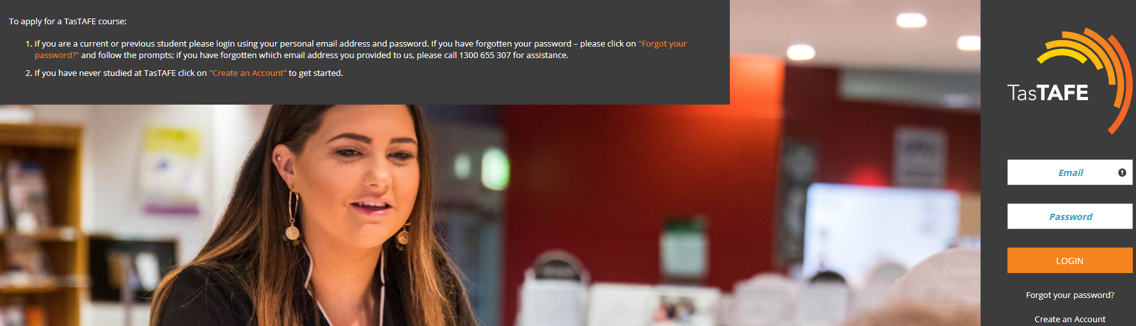

- When you have logged in, click on the ‘Your Uploads’ from the left hand menu
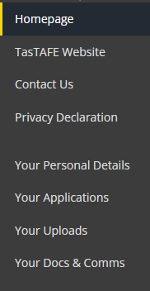
- Using the ‘Evidence Type’ dropdown box, select ‘Evidence of COVID-19 Vaccination’
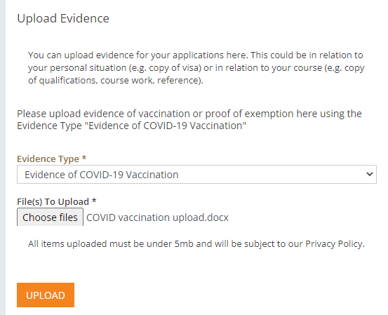
- Under Files to upload click ‘Choose files’ and select your COVID-19 vaccination evidence document from your computer.
- Click on the ‘Upload’ button.
- You’re done!
If you need assistance, please call us on 1300 655 307.
Note: While you are a student with TasTAFE, it is important you regularly visit the COVID-19 Updates page on our website for information that may impact you. This page is updated frequently in response to the COVID-19 pandemic.

