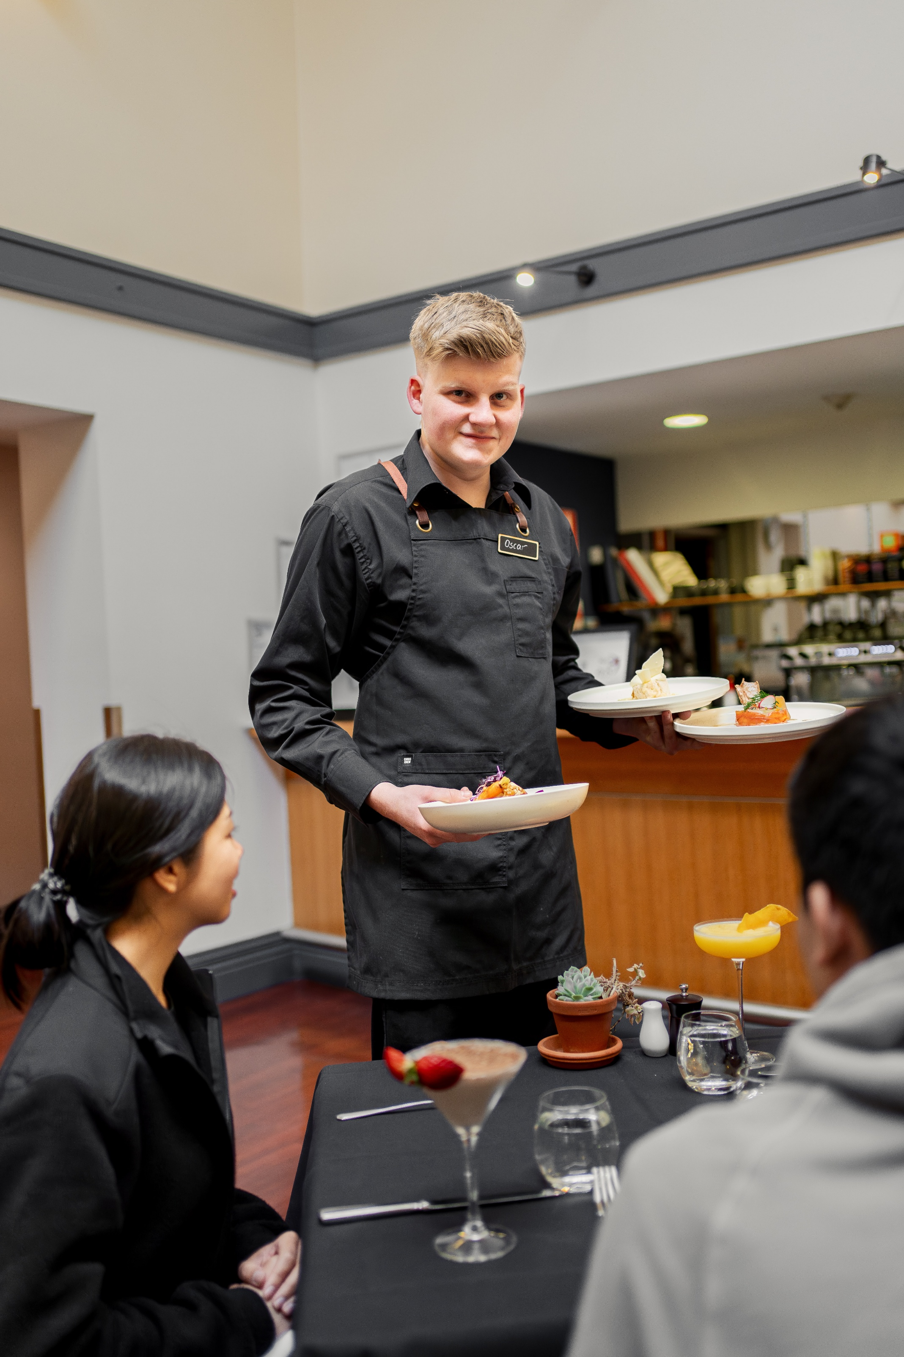



Before You Start

# Before You Start

## When you begin your training with us, we’ll provide a learner orientation and course induction.

Your online or classroom orientation and induction includes things like an introduction to your workshop, studio, lab or kitchen, an overview of TasTAFE’s online learning system (Canvas), relevant safety information and expectations, and information about the structure of your course, assessments and work placements (if applicable).

This ensures your learning experience is rewarding, safe, fair and equitable. You’ll receive information about:

* the TasTAFE Student Code of Conduct
* your rights and responsibilities
* academic misconduct (such as plagiarism, collusion and cheating)
* discrimination and harassment
* student supports
* insurance coverage for learners
* emergency evacuation
* first aid; and
* work health and safety.

This guide will help you get ready to start learning at TasTAFE.

**Acknowledgement of Country**

We pay respect to the traditional and original owners of lutruwita/Tasmania, the palawa people. We pay respects to Elders past and present, along with today’s Tasmanian Aboriginal community and we acknowledge their continuing connection to the land, air, sea and waterways which we all live, learn and work together on.

## Code of conduct

All members of the TasTAFE community can expect an environment and interactions that are:

* Safe and healthy: everyone feels physically, psychologically and emotionally safe. We work safely and to the specific requirements of the learning area we are in.
* Respectful and considerate: we treat each other with respect. No-one faces intimidation, aggression or violence. Everyone is free to participate in their learning or work activities. Diversity is embraced.
* Fair and equitable: everyone is treated fairly and harassment, bullying or intimidation are not tolerated. Everyone can access the TasTAFE experience, and no-one faces disadvantage or discrimination.
* Honest and legal: we act lawfully and follow TasTAFE’s policies and procedures.

## Your rights and responsibilities

We’re committed to providing you a safe and supportive study environment that reflects contemporary workplace standards across all learning environments, campuses and training facilities.

As a TasTAFE learner, there are rules and expectations guiding your behaviour and safety, as well as academic standards that apply to your studies.

[Visit the TasTAFE website for more information about your rights and responsibilities](https://www.tastafe.tas.edu.au/students/learning/rights-and-responsibilities).

## Facilities

We have a range of general facilities in place to meet the diverse needs of learners, including multi-faith prayer rooms, parenting rooms, kitchenettes, vending machines and all-gender toilets.

### All gender toilets

All-gender toilets are for people of all gender identities and expressions. We invite you to use the toilet facilities that affirms your gender and makes you feel comfortable.

### Accommodation

Student accommodation is available at our Alanvale and Clarence campuses.

Each residence has a lounge and dining area, kitchenette, bathroom with separate toilet, laundry, access to public phones, vending machines and a range of table sports including table tennis and pool tables.

Single bedrooms contain a bed and bedding (on request), desk and chair, desk lamp, built-in wardrobe and heater. Wheelchair access is available.

Students are required to self-cater.

[Read more information or book accommodation](https://www.tastafe.tas.edu.au/students/student-services/accommodation).

### Cafes and canteens

Cafes or canteens are on campus at Alanvale, Burnie, Campbell Street, Drysdale Hobart and Clarence. Opening hours vary across campuses.

### Childcare

Privately operated childcare centres are located near the Alanvale, Devonport and Clarence campuses, offering services from Monday to Friday.

There is often high demand for services. Contact the childcare centre for enquiries:

* North: Lady Gowrie Education and Care Centre (next to Alanvale Campus)
* North-West: Malangenna Children’s Centre (next to Devonport Campus)
* South: Flagstaff Gully Child Care Centre (next to Clarence Campus).

### Parking

Free parking is available at the following campuses:

* North: Alanvale
* North-West: Burnie and Devonport
* South: Bender Drive and Clarence.

Council parking is available near the following campuses:

* South: Campbell Street, Drysdale Hobart, Hunter Street
* North: Drysdale Launceston and Inveresk
* North-West: Drysdale Market Square.

Allocated areas for disability parking are available for eligible learners. If you have a generic government-allocated disability parking permit, you can use it. To access these spaces short-term, or for any queries, contact the Disability Liaison Officer in your region or [book an appointment](https://www.tastafe.tas.edu.au/students/support).

## Campus maps

Site maps of most of our campuses and training facilities are available on the TasTAFE website:

* [Alanvale Campus](https://www.tastafe.tas.edu.au/campuses/alanvale-campus)
* [Burnie Campus](https://www.tastafe.tas.edu.au/campuses/burnie-campus)
* [Campbell Street Campus](https://www.tastafe.tas.edu.au/campuses/campbell-street-campus)
* [Clarence Campus](https://www.tastafe.tas.edu.au/campuses/clarence-campus)
* [Devonport Campus](https://www.tastafe.tas.edu.au/campuses/devonport-campus)
* [Drysdale Hobart](https://www.tastafe.tas.edu.au/campuses/drysdale-campus-hobart)
* [Drysdale Launceston](https://www.tastafe.tas.edu.au/campuses/drysdale-campus-launceston)
* [Freer Farm](https://www.tastafe.tas.edu.au/campuses/freer-farm-training-facility,-burnie)
* [Bender Drive](https://www.tastafe.tas.edu.au/campuses/metal-engineering-training-facility,-bender-drive).

## Insurance coverage

The Tasmanian Risk Management Fund (TRMF) is the Tasmanian Government’s self-insurance fund. It provides personal accident cover for learners enrolled at TasTAFE and if you participate in an approved TasTAFE work placement.

Learners (including apprentices) participating in regular training activities (such as classroom work, workshops and excursions) are not covered for personal accidents or injuries by the TRMF.

## Children on campus

We understand that sometimes children of learners may need to attend a campus for short, occasional periods of time.

If you need to bring your child with you to TasTAFE, talk to your teacher about your needs.

All children must be accompanied and under the direct supervision of a parent or adult when on a TasTAFE campus.

Places on campus that may be suitable for children include libraries, cafes or canteens, learner common rooms and parenting rooms. Leaving children unattended in any of the above areas including TasTAFE libraries is not permitted.

## Breastfeeding support

If you want to breastfeed your child on campus, speak to your teacher about any adjustments you may require, including flexible breaks for breastfeeding or expressing.

Your teacher will help to arrange a comfortable and clean space for breastfeeding and expressing (where a parenting room is not provided, a private space can be requested), as well as storage facilities so breastmilk is stored safely.

## Animals on campus

TasTAFE allows assistance and companion animals on campus, in line with our *Assistance & Companion Animals Procedure*.

Please speak with a Disability Liaison Officer for more information and assistance. [Book an appointment](https://www.tastafe.tas.edu.au/students/support).

## No smoking

All TasTAFE campuses are designated smoke-free areas within the campus boundary (including in vehicles). This covers all methods of smoking or vaporising, including cigarettes, electronic cigarettes, pipes and cigars.

You must comply with all “No Smoking” signs and directions.

## Driving on campus

You’re required to comply with all TasTAFE campus traffic and parking directions, including speed limits. Take care when driving on campus and adhere to the speed limit.

## Alcohol and other drugs

Do not attend a TasTAFE campus under the influence of alcohol or other drugs or be in the possession of alcohol or other drugs on campus.

Prescription and over-the-counter medicines are allowed. If you are affected by medication (such as drowsiness or dizziness), you should not attend a TasTAFE campus.

## Provide your preferred name

Provide your preferred name on your student details form or use the change of details form. Your preferred name will flow through to your TasTAFE login, including Canvas and email communications. If your name has changed since creating your USI, you’ll need to update your details with us and on the [USI website](https://aus01.safelinks.protection.outlook.com/?url=https%3A%2F%2Fwww.usi.gov.au%2F&data=05%7C02%7Ccharles.rawlings-way%40TasTAFE.tas.edu.au%7Cbb9658c8288a4d2b64c608dcd20f61a0%7Ca9be3ac70c60491e8b3ba32f8f46aec8%7C0%7C0%7C638616213915258831%7CUnknown%7CTWFpbGZsb3d8eyJWIjoiMC4wLjAwMDAiLCJQIjoiV2luMzIiLCJBTiI6Ik1haWwiLCJXVCI6Mn0%3D%7C0%7C%7C%7C&sdata=AEAOH2QTxTPqDYCZ8zMir5hyvepM3StFGDXZVaRBM94%3D&reserved=0).

Please note: Your legal name will be used on Testamurs, Statements of Attainment and student ID cards.

## Student ID card

Once you are enrolled, you’ll be eligible to [get a student ID card](https://www.tastafe.tas.edu.au/students/apply-and-enrol/finalise-your-enrolment) if your course is at least 6 weeks long (in some cases you may be able to get a card for shorter courses).

Your student ID card is also your TasTAFE library card and can be used as a form of general ID. Your student ID card also provides access to concessional rates for participating services such as transport and the movies.

Please note that your student ID card must be issued in your legal name as it is used for identification purposes.

## Change of details

To make sure you receive important information from us, let us know if you change your name or address.

If you need to update your contact details, call us on [1300 655 307](tel://1300655307/) or update your details in your TasTAFE Student Portal account.

## Get ready to study: Top 10 checklist

1. I have a Unique Student Identifier (USI).
2. I have created my TasTAFE Student Portal account.
3. I have a device other than my phone that I can use for study, and this device can do the tasks needed for TasTAFE online study.
4. I know my TasTAFE username and password.
5. I know where and how to borrow a laptop to take to class if I need to.
6. I can access my TasTAFE email account and Microsoft Office 365.
7. I can access and use CANVAS and Microsoft Teams.
8. I can access the TasTAFE Library webpage.
9. I have contact details for my teacher ready in case I have technical issues or can’t attend class.
10. I have made an appointment with Student Support – an Aboriginal Support Officer, Counsellor, Disability Liaison Officer or International Student Advisor – if I need help with these things.

## Keep in touch

Staying connected and keeping you informed while you study at TasTAFE is important to us. We do this through our student newsletters, emails and SMS.

If you have a question or need some support, contact us via:

* [1300 655 307](tel://1300655307/)
* [info@tafe.tas.edu.au](mailto:info@tafe.tas.edu.au)
* [www.tastafe.tas.edu.au](https://www.tastafe.tas.edu.au/)

… and don’t forget to be social! Follow us on [Facebook](https://www.facebook.com/TasTAFE/) and [Instagram](https://www.instagram.com/tastafe/)

DISCLAIMER: This information is correct at the time of publication (December 2024). Every effort has been made to ensure details are correct and accurate, however TasTAFE reserves the right to change information without notice.