TasTAFE Nursing Philosophy

The Diploma of Nursing program is committed to person-centre care that encompasses the professional relationships with others, using critical thinking to provide holistic care. It is a process of teaching students to ‘think like a nurse’ (Levett-Jones, 2017). It puts the patient first and is considerate of the community.

To achieve competence, nurses need to work collaboratively with health professionals whilst demonstrating their awareness of regulatory requirements. Enrolled nurses apply their knowledge, that is an understanding of information, skills to undertake clinical tasks and attitude, their ‘thinking and behaviour’ (Nursing and Midwifery Board of Australia, 2017) to demonstrate holistic care.

To promote the development of critical thinking skills required to undertake clinical reasoning, students are exposed to case-based learning. According to Kaddoura (2011) this form of learning for nursing students, supports active engagement and ‘professional practice’. Contemporary real-life scenarios allow students to authentically analyse situations in a safe and supported environment. These case studies increase in complexity to reflect each phase of the program, allowing students to consolidate their nursing competence. TasTAFE’s nursing philosophy fosters an inclusive approach to ensure a meaningful and structured process optimises each student to become a competent nurse to provide quality care in a variety of health settings.

References

Kaddoura, M. (2011). Critical thinking skills of nursing students in lecture-based teaching and case-based learning. International Journal for the Scholarship of Teaching and Learning, [online] 5(2), pp.1–2. doi:https://doi.org/10.20429.

Levett-Jones, T. (2017). Clinical Reasoning: learning to think like a nurse. 2nd ed. Victoria: Pearson Education Australia.

Nursing and Midwifery Board of Australia (2017). Enrolled Nurse Standards for Practice. [online] Nursing and Midwifery Board of Australia. Available at: https://www.nursingmidwiferyboard.gov.au/Codes-Guidelines-Statements/Professional-standards/enrolled-nurse-standards-for-practice.aspx

Conceptual framework
TasTAFE aims to promote and maintain the highest teaching standards, corporate governance, and training outcomes. To achieve this TasTAFE follows a modern constructivist framework design process (Australian Journal of Adult Learning, November 2016). This consists of determining the needs of the learners, defining the end goals and objectives of instruction, designing and planning assessment tasks, designing teaching and learning activities to ensure the quality of instruction and to meet industry expectations. (Norbert M. Seel, Thomas Lehmann, Patrick Blumschein, Oleg A. Podolskiy, 2017)
In Australia, nurses must meet the Nursing and Midwifery Board's (NMBA) professional standards in order to practice. Professional standards define the practice and behaviour of nurses and include codes of conduct, standards of practice, and codes of ethics. The Nursing and Midwifery Board, Australia, (NMBA www.nursingmidwiferyboard.gov.au) is responsible for the development and oversight of standards of nursing practice (www.ansat.com.au/home).
Nurses are the most present of healthcare professionals and promote wellness, quality of life and dying with dignity. Nurses build a therapeutic relationship with clients’ and are best able to read the emotional cues of patients and establish human connections and relationships, thus the client becomes the centre of care (NMBA 2017). Intrinsic to the art of nursing, compassion aligns with nurses’ highest professional ideals and compassion is an emotional response to reduce another’s pain or suffering (Goetz, Dacher, & Simon-Thomas, 2010).
Nurses are highly regarded as a profession and therefore strive to maintain professional standards of practice to uphold public expectation of the profession (NMBA `2017)
Just as nurses have a person-centred approach to care, so too does TasTAFE have a student-centred approach to nursing education.
TasTAFE recognises nursing practice is synergistic with advancement in medical science, clinical practice, and client expectations across the health continuum. Nursing continues to evolve and our teachers are passionate about nursing as a profession and recognise the changes in practice and the related clinical evidence. TasTAFE nursing teachers recognise that each student has their own life experiences, educational experiences and values which will influence their nursing education journey and inform their nursing practice. We achieve a student-centred approach by ensuring students become familiar with a core group of teachers specifically allocated to each stage of their nursing education journey. From the point of induction through to graduation, students will have contact with teachers and support staff who know them by name and celebrate student achievement.
The Diploma of Nursing program requires graduates to develop through design both technical and theoretical knowledge required to provide nursing care for people across different stages of life in a range of settings across the health sector (Industry Skills Council 2015). Graduates of the Diploma of Nursing program require well developed cognitive, technical and communication skills, and have the ability to apply these skills in dynamic and changing environments (Australian Qualifications Framework Council 2013).
A modern constructivist framework underpins the TasTAFE Diploma of nursing programme. Our teachers are student focussed and consider previous learning to be a foundation upon which to build and expand knowledge (Australian Journal of Adult Learning, November 2016). Our constructivist andragogy is informed by theorists such as Lev Vygotsky, Jerome Bruner, David Ausubel (Jiayu Zhou, 2020). The Diploma of nursing program at TasTAFE applies social constructivism principles by using the pedagogical approach of Flipped Learning, whereby learner-to-content interaction is undertaken via students engaging with learning materials presented in TasTAFE’s Learning Management System Canvas (Kim, Jung de Siqueira & Huber 2016). This allows ‘in-class’ time to be dedicated to creating rich learning opportunities through social interaction and peer review (Flipped Learning Network 2014). Our dedicated teachers facilitate student-centred learning activities during remotely facilitated tutorials conducted via Zoom and bring to life the complexities of nursing practice during hands-on practical simulation learning opportunities.
TasTAFE recognises that students bring a wide array of previous educational experiences with them when commencing the Diploma of Nursing program. Many students will not have experienced learning through a Flipped Learning model. TasTAFE facilitates an intensive induction program for all students to develop the technical and personal study skills that are required to be successful in the program. During this induction period, our teachers work intensely with students to identify individual needs to support their study and make recommendations of how to access any additional supports that may be required. Once students have the basics of how to engage in learning in the Flipped Learning model, they are better prepared to launch into course specific materials.
To develop students throughout the Diploma of Nursing program, TasTAFE scaffolds students learning experiences using a spiral curriculum structure. The spiral curriculum approach (Figure 1) allows students to construct learning through repeated experience, practice and critical examination of concepts and technical skills that increase in complexity in each revisitation (Ross, Noone, Luce & Sideras 2009). For example, at the base of the spiral students may be introduced to evidenced based approaches to controlling the spread of infection such as handwashing. As learning progresses, students will continuously revisit infection control measures through participation in simulated client care scenarios. Finally, students will be able to demonstrate their role and responsibilities in relation to preventing and controlling healthcare-associated infection through participation in complex care scenarios and identifying relevant standards of practice.
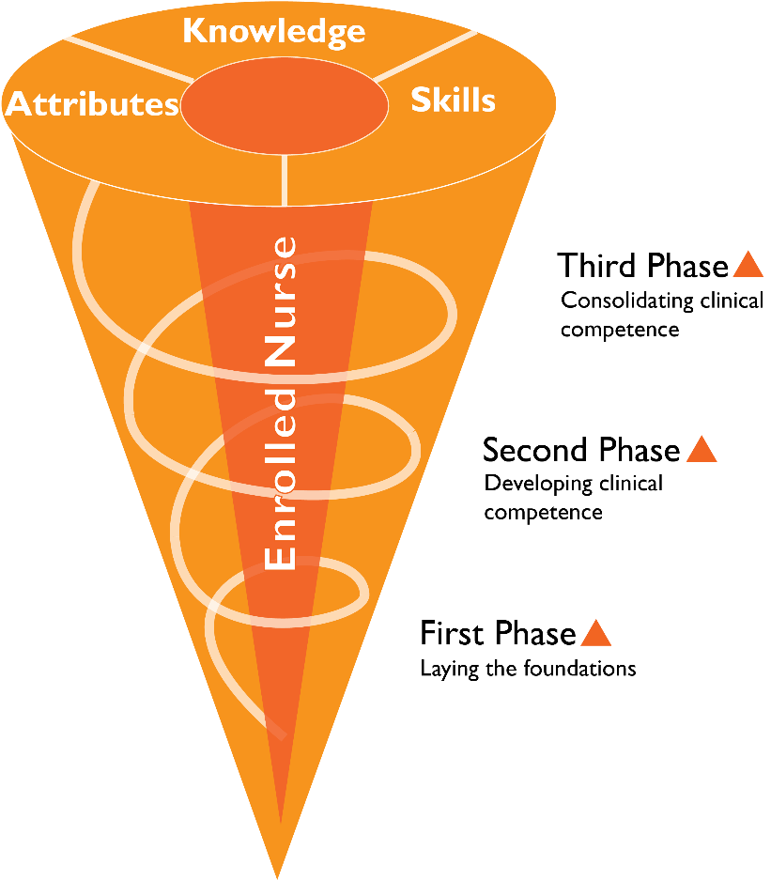
Figure 1. The spiral curriculum (© 2019 TasTAFE) Adapted from the Revised Blooms Taxonomy (2001)
For students to be able to achieve the complexity of knowledge and skills required, the spiral curriculum is dependent not only on repetition and practice, but upon critical examination of these experiences. Throughout the Diploma of Nursing teachers model and teach students to become critically reflective practitioners through the use of the clinical reasoning cycle (Figure 2) (Levett-Jones ed. 2013). The clinical reasoning cycle is a process by which nurses collect and process information in order to understand a situation so they can plan how to address problems, whilst encouraging them to evaluate, reflect and learn from the process (Levett-Jones, Hoffman, Dempsey, Jeong, & Noble 2012).

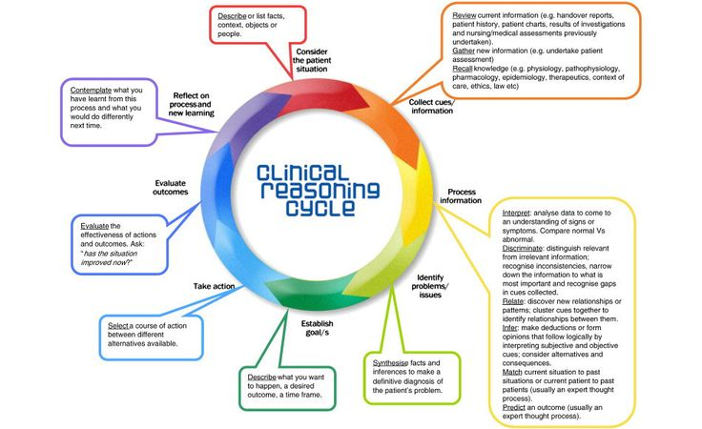

Figure 2. The clinical reasoning cycle (Levett-Jones 2013).
The spiral curriculum represents the structure of the Diploma of Nursing program in three phases of learning. The three phases of learning represented are interdependent, however distinction between the phases can be identified by Professional Experience opportunities at the end of each phase. Within each phase of learning students are provided with facilitated learning opportunities of a theoretical nature, followed by practical ‘hands on’ learning to allow students to develop an understanding of how learned theory underpins nursing practice.
Practical learning opportunities initially focus on specific skills related to a distinct unit of study, such as clinical documentation.
The application of knowledge and skills through best practice methodologies (Koutoukidis & Stainton 2017) is linked intrinsically to the Aged Care Quality and Safety Standards (2018) and the NSQHS (2017). This underpinning creates understanding, synthesis and how these standards apply to practice across the health continuum.
This methodolgy ensures that all Diploma of Nursing graduates understand their role in quality improvement and risk minimisation. Clinical skills practice and assessment allow students to develop towards demonstrated competence of the Nursing and Midwifery Board of Australia Enrolled Nurse Standards for Practice (Nursing and Midwifery Board of Australia 2017).
The process used to facilitate the development of clinical skills encourages students to develop an understanding of the Enrolled nurse scope of practice through use of the Decision-Making Framework (Nursing and Midwifery Board of Australia 2013). Students are encouraged to reflect on their performance and learning through a self-assessment process integrated with the Enrolled Nurse Standards for Practice (Nursing and Midwifery Board of Australia 2017). Developing students’ abilities to self-assess throughout the Diploma of Nursing encourages students to reflect upon their own learning needs to meet established objectives. Embedding these principles of self-regulation and responsibility for their own learning within the Diploma of Nursing is integral in developing graduates that are self-directed and committed to the life-long learning requirements of a professional nurse (Su 2015).
As learning progresses within the phases, distinct clinical skills are drawn together to provide students with the opportunity to learn within simulated scenarios. Simulations are designed to reflect ‘real world’ conditions in a variety of health care settings and provide opportunities to develop cognitive, technical and communication skills required for a Diploma graduate (Australian Qualifications Framework Council 2013). Simulated scenarios are designed to allow students to engage with the Clinical Reasoning Cycle to encourage deeper levels of learning (Levett-Jones ed. 2013). Simulated scenarios are used to monitor students learning towards achieving stated learning outcomes through a collaborative learning process utilising peer and teacher feedback. Simulated scenarios are used as a process to determine achievement of performance against unit outcomes and to determine readiness for Professional Experience.

References
Aged Care Quality and Safety Commission (the Commission): Aged Care Quality and Safety Commission Act 2018 and the Aged Care Quality and Safety Commission Rules 2018 (Rules).
Australian Commission on Safety and Quality in Health Care 2017 NSQHS Standards, National model clinical governance framework. Australian Commission on Safety and Quality in Health Care, Sydney.
Australian Journal of Adult Learning, November 2016, Contemporary constructivist practices in higher education settings and academic motivational factors, Dr Dorit Alt, Volume 56, Number 3.
Australian Qualifications Framework Council 2013, Australian Qualifications Framework, South Australia, viewed 27 May 2019, <https://www.aqf.edu.au/sites/aqf/files/aqf-2nd-edition-january-2013.pdf>
Flipped Learning Network 2014. The Four Pillars of F-L-I-PTM viewed 18 January 2021, <https://www.flippedlearning.org>
Industry Skills Council 2015, HLT54115 Diploma of Nursing, Canberra, viewed 72 May 2019,
training.gov.au - HLT54121 - Diploma of Nursing
Enrolled Nursing: Training Package Update Complete - SkillsIQ :: Skills Service Organisation
Goetz, J., Keltner, D., & Simon-Thomas, E. (2010). Compassion: An evolutionary analysis and empirical review. Psychological Bulletin, 136(3), 351-374.
Jiayu Zhou, University of York, York, YO10 5DD, UK, 2020. Review of Educational Theory A Critical Discussion of Vygotsky and Bruner’s Theory and Their Contribution to Understanding of the Way Students Learn, Volume 03, Issue 04, October 2020
Kim, M, Jung, E, de Sequeira, A & Huber, L, 2016. ‘An investigation into the effective pedagogies in a Flipped Classroom: A case study’, International Journal of E-Learning and Distance Education, vol. 32, no.2, pp. 1-15.
Koutoukidis, G & Stainton, K 2017, Essential enrolled nursing skills for person-centred care, Elsevier Australia, Chatswood, NSW.
Levett-Jones, T (Ed.) 2013, Clinical reasoning: learning to think like a nurse, Pearson Australia, Frenchs Forest, N.S.W.
Levett-Jones, T, Hoffman, K, Dempsey, J, Jeong, S.Y & Noble, D, 2012, ‘The ‘five rights’ of clinical reasoning: An educational model to enhance nursing students’ ability to identify and manage clinically ‘at risk’ patients’. Nurse Education Today, vol. 30, no. 6, pp. 515–520, viewed 14 May 2019, JSTOR Arts and Sciences IV, Springer.
Norbert M. Seel, Thomas Lehmann, Patrick Blumschein, Oleg A. Podolskiy, 2017, What is Instructional design? (Theoretical foundations) Pages 1-17
Nursing and Midwifery Board of Australia. 2013. Nursing practice decisions summary guide (DMF) https://www.nursingmidwiferyboard.gov.au/Codes-Guidelines-Statements/Frameworks.aspx
Nursing and Midwifery Board of Australia 2017, Enrolled nurse standards for practice, Melbourne, viewed 27 May 2019, <https://www.nursingmidwiferyboard.gov.au/Codes-Guidelines-Statements/Professional-standards/enrolled-nurse-standards-for-practice.aspx>
Ross, A, Noone, J, Luce, L & Sideras, S, 2009, ‘Spiraling evidence-based : practice and outcomes management in an undergraduate curriculum : a systematic approach’, Journal of nursing education, vol. 48, no. 6, August, pp. 319-326, viewed 14 May 2019, CINAHL Complete, EBSCOhost.
Su, Y 2015, ‘Ensuring the continuance of learning : the role of assessment for life-long learning’, International review of education, vol. 61, no. 1, pp. 7-20, viewed 14 May 2019, JSTOR Arts & Sciences IV, Springer. “The Taxonomy in Use” A Revision of Bloom’s Taxonomy of Educational Objectives : Section III of A Taxonomy for Learning, Teaching, and Assessing: Bloom’s Taxonomy center for teaching, Vanderbilt University, Viewed 28 September 2023

