TasTAFE RESIDENCE 2024
Self-contained accommodation

Conveniently located onsite at the Clarence Campus in Hobart and Alanvale Campus in Launceston, the two TasTAFE Residences offer clean, comfortable and affordable accommodation options for TasTAFE students.
TasTAFE Residences provide four-share accommodation in self-contained motel style units, for both short- and long-term stays.
Long term stays greater than 2 weeks will be charged a weekly rate. Stays less than 2 weeks will be charged a daily rate. Short term guests Sunday to Friday term dates, cannot stay Friday or Saturday nights unless pre organised.

Accommodation
Both the Alanvale and Clarence Residences have two buildings – each containing 11 units.
Each unit contains between four and five lockable
single bedrooms with shared access to the unit’s common areas (kitchen, bathroom and lounge room).
Guests have access to the Residence common room/lounge area, and outdoor BBQ area.
The common room has CCTV cameras.
TasTAFE students under 18 years of age will be housed with fellow underage guests in either gender specific or non-specific units. These units are housed in a secure building, but the building may contain student guests over the age of 18. Guardians will need to complete admission form for underage guests.
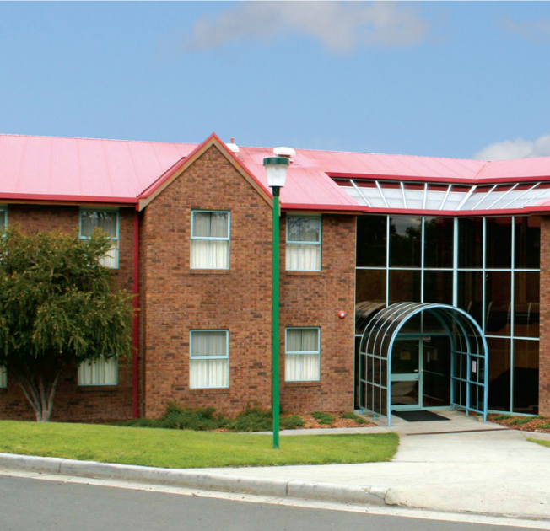Depending on availability units for over 18 years of age guests may not be gender specific as TasTAFE offers gender specific or non-specific options but is subject to demand.

Each Residence contains:
- vending machines
- a fully equipped laundry – no fee
- table tennis and/or pool tables

Each unit contains:
- 4–5 single bedrooms
- lounge/dining area with colour TV
- fully equipped kitchenette (including fridge, toaster, kettle, cookware, cutlery, crockery and a stove or microwave)
- common lockable bathroom with shower and separate lockable toilet
- heating

Single bedrooms contain:
- desk and chair
- bed (king single) with pillow, pillowcase and mattress cover. A linen pack consisting of sheets and donna can be hired for a daily fee. For long term stayers’ linen pack is provided but cleaning is the responsibility of the guest
- built in wardrobe and shelving
- heater.
*All common areas are serviced weekly and provided with additional cleaning supplies, when a guest leaves, room and unit common area are cleaned prior to the arrival of a new guest.

Location
Alanvale Residence is located at TasTAFE’s Alanvale Campus on the banks of the Tamar River.
The Alanvale residence is just a five-minute drive from the Launceston CBD and the seaport precinct, which provides a wide range of food and shopping options.
Clarence Residence is located on the grounds of the Clarence Campus in Warrane on Hobart’s Eastern Shore.
Just a few minutes from Eastlands Shopping Centre, Rosny bus mall and Village Cinemas, the Clarence Residence is also conveniently located to a range of restaurants and takeaway options.

Availability
Accommodation at the Alanvale and Clarence Residence is available all year round for long term stayers.
Casual guests can stay term times Sunday to Friday.
Check in is from 3:30pm and ideally no later than 8:00pm.
Guests will be provided electronic PIN details of how to access the gate, building and unit and code for the key box located in the unit for their room.
Check out is 9.00 am next day.

Rates
Our accommodation rates are incredibly competitive, making it affordable to travel and stay overnight in the north or south of the state.
TasTAFE students:  - $40 per night  - $220 (seven nights), greater than 2 weeks stay | - Linen pack $5 per night  - Towel $4 per night  - Includes a linen pack but no towel
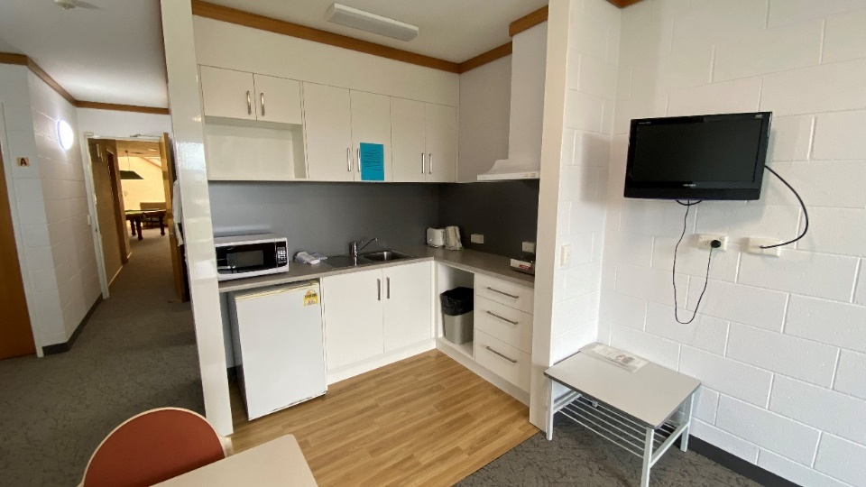

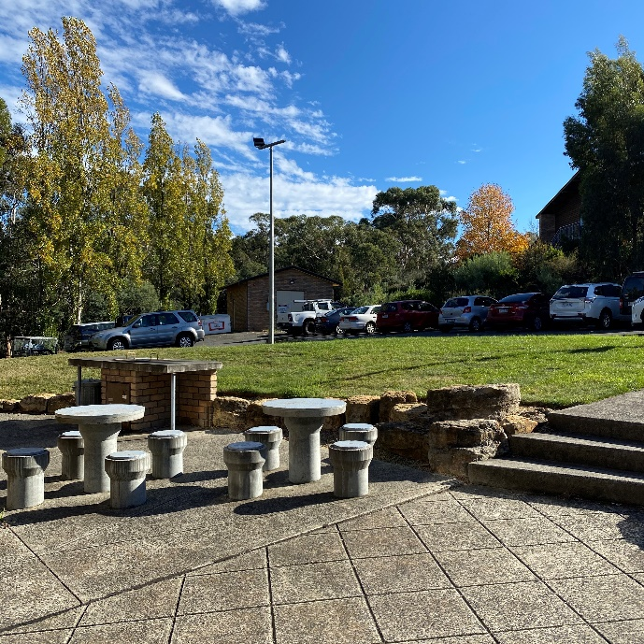

Things you need to know…
- Common area of units are serviced weekly
- car parks are located next to each building and are well lit
- metro buses pass the campus grounds on a regular basis
- lawn area and BBQ facilities are available for guest use
- management is onsite between 8.00am and 4.30 weekdays. After hours emergency services are available.
- No consumption of alcohol, use of drugs, smoking or vaporing is permitted.
- Each unit is secured external access by unique PIN and each room is lockable.
- Buildings only accessible by unique PIN
- Buildings are monitored by security and security enters building at night times on a random basis.
- Guardians are required to agree to terms of admission for underage students, Authority lasts for 6 months and needs to be renewed until the guest is over 18 years of age. For first booking please email for further assistance.
- The Residence is bound by TasTAFE’s code of conduct.

Want to book your stay?
To check availability, book a room or find out more about our Residences, please go to our website:
www.tastafe.tas.edu.au/accommodation
If requiring further assistance:
Alanvale Residence
Phone: 1300 655 307 (office hours)
Phone: 6777 2683 (after hours)
Email: studentresidencenth@tastafe.tas.edu.au
Clarence Residence
Phone: 1300 655 307 (office hours)
Phone: 6165 6109 (after hours)
Email: studentresidencesth@tastafe.tas.edu.au

When booking for a casual stay full payment is required to confirm the booking. Bookings will receive a confirmation email/SMS 48 hours prior to your check-in.
Long term stayers will be required to pay the first week in full to confirm booking.

