


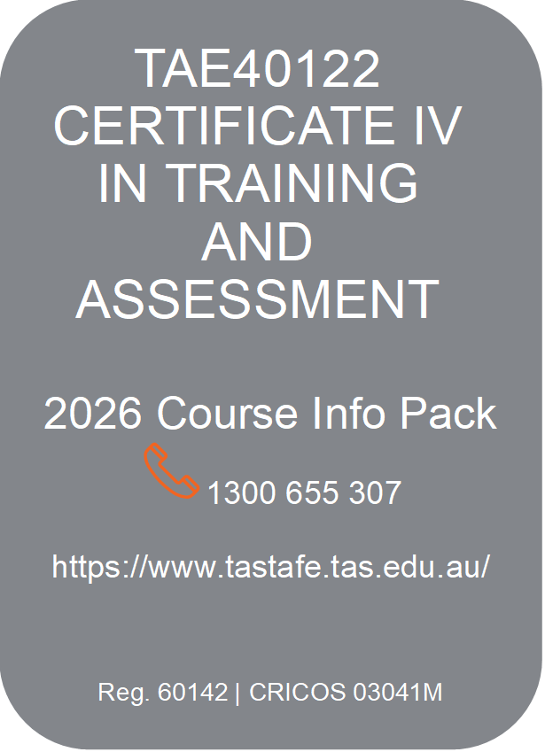



Are you ready to use your industry skills to develop your career as a trainer and assessor?

What is TAE40122 and who is it for?

This highly sought after qualification, TAE40122 Certificate IV in Training and Assessment, commonly known as ‘TAE’, is the minimum requirement for teachers, trainers and assessors (VET Practitioners) in the vocational education sector (VET) in Australia.

It focusses on learning how to conduct good quality training and assessing, aligned to Nationally Recognised Training Products.

It is suitable for those:

- with qualifications and current, broad experience within their industry who wish to become teachers, trainers and/or assessors in the VET sector
- wanting to give back to their industry through training the next generation

We want you to leave with the confidence and skills required of a vocational trainer and assessor.

Remember, TAE is the beginning of your VET journey.

What is the role of a VET practitioner?
A VET practitioner is a dual professional who works to build skills and knowledge in learners in their chosen vocation. They must have skills and currency in a vocational field and good skills in the areas of teaching, learning and assessing.
They will work with new technologies and incorporate a broad range of teaching techniques into practice to meet the needs of all learners. VET practitioners collaborate with industry, learners and colleagues; are creative and enjoy variety in each working day.
Long term career prospects are enhanced through constant innovation in teaching practices and industry requirements.



Is this qualification for me?
TAE40122 is suitable if you are intending to conduct structured training and/or assessment using national training products in a Registered Training Organisation (RTO).
It provides you with an understanding of the intricacies of the VET sector in Australia and develops your skills and knowledge to effectively facilitate and assess in contemporary training and learning environments.
*Skill sets or non-accredited courses may be more suitable if you are intending to deliver and assess non-accredited training.

What are the Entry Requirements?
Applicants must be able to demonstrate vocational competency in their proposed training and assessing area. This will be evidenced through providing:

- your vocational qualification i.e. trade certificate or above
- your resume – showing broad and current experience in using the qualification
We also require:
- achievement of ACSF level 3 English and level 2 Maths in the TasTAFE LLN assessment.
- An online individual course conversation
(A conversation is not required for entry into the TAESS00028 Work Skill Instructor Skill Set).

Why choose TasTAFE?
Our focus is on learning - building your knowledge and practice through scheduled, real time, evening sessions designed to be interactive, fun and engaging.
Webinars are recorded so you can catch up when life happens!
We pride ourselves on creating a great learning pathway preparing you for a successful VET career.

TAE40122 Course Overview

How will I learn?
Online delivery via webinars (See the synchronous webinar schedule on last page of the Info Pack)

The TAE40122 program includes:
- Online induction
- Online learning resources – you will be expected to engage with the learning resources prior to webinars
- Online Webinars – structured learning and interaction is provided to assist your progress
- Canvas eLearning platform where you can access all your learning resources, upload assignments and communicate with your teacher
- Online support sessions that are scheduled throughout your course

Course structure
We have designed the program to scaffold your learning experience. We strongly recommend commencing the program with the TAESS00028 Work Skill Instructor Skill Set, providing you a with a ‘taste’ of the vocational training environment so you can decide if this is the right pathway for you!

TasTAFE offers:
- One course enrolment into the TAE40122 – fixed schedule. We offer 3 intake dates for 2026
OR
- Stackable Skill Set Pathway (5 Skill Sets in total) – gives flexibility to start when you like. Note: you are required to enrol in each skill set one at a time and complete all 12 units to gain the full qualification.


How long should it take me?
The amount of time to complete this qualification will vary according to your knowledge, skills and experience in the VET sector.
We offer a 12-month enrolment period for the fixed schedule course.
It is important to TasTAFE to maintain the integrity of this qualification and provide learning opportunities that lead to the required outcomes so that this qualification can be used confidently and professionally.
The amount of training provided is only a portion of the overall learning requirement, and you are expected to undertake additional structured and nonstructured learning to complete the program.
Most learners would require 10 -12 hours per week for learning and assessment in addition to scheduled webinar sessions.

What are the TAE40122 units?
There are 12 units required to complete this qualification – 6 core units and 6 elective units in total. These are offered as five (5) separate skill sets plus the TAELLN421 elective unit.


TAESS00028 Work Skill Instructor Skill Set
- TAEDEL311 Provide work skill instruction (Elective unit)
- TAEPDD401 Work effectively in the VET sector (Core unit)

TAESS00017 Workplace Supervisor Skill Set
- TAEASS311 Contribute to assessment (Elective unit)
- TAEDEL414 Mentor in the workplace (Elective unit))
- TAEDEL311 Provide work skill instruction – completed in above skill set

TAESS00021 Facilitation Skil Set
- TAEDES412 Design and develop plans for vocational training (Core unit)
- TAEDEL411 Facilitate vocational training (Core unit)

TAESSS00019 Assessor Skill Set
- TAEDES411 Use nationally recognised training products to meet vocational training needs (Core unit)
- TAEASS412 Assess competence (Core unit)
- TAEASS413 Participate in assessment validation (Core unit)

TAESS00023 Online Learning & Assessment Skill Set
- TAEDEL405 Plan, organise and facilitate online learning (Elective unit)
- TAEASS404 Assess competence in an online environment (Elective unit)

Plus, one additional elective unit
- TAELLN421 Integrate core skills support into training and assessment unit (elective unit)
OR you may bring one eligible elective unit from a current Certificate III or above qualification).
Enrolment in this elective unit will occur in your final skill set for the stackable skill set pathway.

How much will the TAE40122 online course cost?

- The full qualification course fee is $3755 – paid upfront before the course commences (one enrolment). Note that a 6-month payment plan is available.

OR

- Individual Skill Set fees as shown below - 5 separate enrolments for the stackable skill set pathway to complete the full qualification.

Skill Set | Fee
TAESS00028 Work Skill Instructor Skill Set | no fee
TAESS00021 Facilitation Skill Set | $1100
TAESS00017 Workplace Supervisor Skill Set | $940
TAESS00019 Assessor Skill Set | $1100
TAESS00023 Online Learning and Assessment Skill Set | $630



Fee Payments
All fees must be paid for prior to entry into your chosen program.
You cannot access learning and assessment materials without this being completed.
A refund will only apply if you formally withdraw 72 hours prior to the commencement of the course.
If you are enrolled in a course that has already commenced, there is no refund.

*2026 Course fees – may be subject to change and include the cost of processing credit transfer results.

How will I be assessed?
You will gather and develop the evidence required in a suitable training and assessment environment in your own workplace or a registered training organisation (RTO), using real work activities.
You will be provided with detailed assessment tasks once you have commenced the course. These tasks will be completed outside of scheduled learning times.


Am I eligible for recognition or credit transfers?
TasTAFE is committed to ensuring the opportunity to apply for recognition is made available to all learners, and as far as possible, the process is streamlined, individualised, holistic and task based.
You are able to have your competency from prior learning and work experience within the VET sector recognised in this qualification through the following arrangements:

- Credit Transfer: If you have successfully completed training with TasTAFE or another RTO, relevant verified units may be eligible for credit transfer.

- Recognition: If you have skills and experience and are able to demonstrate competence and currency in the VET sector aligned to a unit or units of competency, you may be eligible for recognition.
- Recognition assessment requires no less evidence than what is established for general course assessment.
- Recognition is conducted according to the principles of assessment and rules of evidence the same as course-based assessment.

Key methods of providing assessment evidence for recognition may include, but are not limited to:
- portfolio of workplace documentation related to unit requirements
- observation of performance in the workplace and/or simulated workplace environment
- questioning (professional competency conversation)

If you wish to gain further information about recognition, please contact us to arrange an initial discussion with our Recognition Consultant. Recognition requires enrolment and payment of fees the same as any other assessment pathway.

Skill Sets | Assessment Tasks
TAESS00028  Work Skill Instructor Skill Set | - Deliver three work skill instructions to an individual or small group  - Questioning/Professional conversation  - Scenario-based assessment
TAESS00017  Workplace Supervisor Skill Set | - Deliver three work skill instructions to an individual or small group  - Create mentoring plans  - Facilitate at least three (3) mentoring sessions  - Carry out a minimum of three evidence-gathering activities  - Questioning/Professional conversation
TAESS00021  Facilitation Skill Set | - Design and develop training plans, for at least two (2) different units of competency, each featuring at least three (3) consecutive training sessions tailored to the target learner group  - Facilitate face-to-face, in-person, training sessions based on a training product that is nationally recognised or aligned with other recognised frameworks:  - a series of 3 sequential group training sessions of at least 30 minutes duration each to 1 group of at least four (4) learners  - 2 different individual training sessions of at least 30 minutes duration each to a learner who is not part of the above group.  - Questioning/Professional conversation
TAESS00019  Assessor Skill Set | - Customise the assessment process to the candidate  - Conduct a total of at least 6 assessments, at least 1 of which must use recognition of prior learning (RPL), for at least three different learners against at least 2 different units of competency  - Participate in three validation sessions for assessment instruments.  - Participate in three validation sessions for assessment judgements  - Questioning/Professional conversation
TAESS00023  Online Learning and Assessment Skill Set | - Conduct at least two online learning sessions of at least 30 minutes with a group of at least three learners  - Conduct at least two online assessment processes for at least three candidates synchronously and asynchronously  - Questioning/Professional conversation
+ Elective Unit: TAELLN421  Integrate core skills support into training and assessment | - Review previous Facilitation and adjust to meet learner needs  - Review Assessment strategies and adjust to meet learner needs  - Identify core skill needs of units and learners

What will I need to be successful?

You will need:
- a passion for teaching and learning
- a desire for continuous learning
- computer equipment and technology, preferably a laptop or PC as tablets are often too small to work on for long periods of time
- reliable internet, webcam, headset, microphone and speakers
- to organise your own adult learners for practice and assessment tasks for most skill sets

Additionally:
- Facilitation Skill Set: You will require a minimum of four (4) learners (face-to-face and in-person) to complete your facilitation sessions.
- Assessor Skill Set: We highly recommend you attend webinars as much of the assessment is conducted in class time.

Other skills required:
- Digital skills to meet training and assessment requirements, including:
- word processing skills such as saving, filing and retrieving documents
- basic presentation programs such as PowerPoint
- using TasTAFE’s Learning Management System (Canvas)
- using communication tools such as email, Zoom and MS Teams
- navigating online to undertake research
- Language, literacy and numeracy skills to meet training and assessment requirements including:
- developing and reviewing assessment instruments, as well as planning, conducting and validating assessments
- researching, reading and interpreting of National Training Packages
- delivery of one-on-one, group-based and practical work-based training
- delivery of presentations in a number of contexts using a range of skills
- writing a range of documents
- receiving and providing feedback to peers and learners
- conducting assessments, presentations and training, including being observed.

If you do not possess these requirements, support services will be offered for advice about support and pathway options. This may include enrolment into basic computer courses, entry into micro digital sessions, and/or study skills sessions to prepare you before undertaking the course.

Course Schedules
Full course enrolment – Fixed schedule *All dates and times may be subject to change

TAE40122 COURSE 1
Dates: 2 February 2026 to 4 December 2026
Learning Sequence | Synchronous webinar details
Induction | Wednesday 28 January at 5:30–6:30pm
Work Skill Instructor Skill Set | 2 February to 25 February, Monday and Wednesday 5:30–8:30pm
Workplace Supervisor Skill Set | 31 March to 16 April, Tuesday and Thursday  5:30–8:30pm
Facilitation Skill Set | 19 May to 18 June, Tuesday and Thursday  5:30–7:30pm
Assessor Skill Set | 4 August to 17 September, Tuesday and Thursday  5:30–7:30pm
Online Learning & Assessment Skill Set | 20 October to 12 November, Tuesday and Thursday  5:30–7:30pm
TAELLN421 elective unit | Mon 21 and Wed 23 September at 5:30–7:30pm

TAE40122 COURSE 2
Dates: 11 May 2026 to 10 May 2027
Learning Sequence | Synchronous webinar details
Induction | Wednesday 6 May at 5:30–6:30pm
Work Skill Instructor Skill Set | 11 May to 3 June, Monday and Wednesday  5:30–8:30pm
Workplace Supervisor Skill Set | 30 June to 9 July, Tuesday and Thursday  5:30–8:30pm
Facilitation Skill Set | 18 August to 17 September, Tuesday and Thursday  5:30–7:30pm
Assessor Skill Set | 20 October to 3 December, Tuesday and Thursday  5:30–7:30pm
Online Learning & Assessment Skill Set | 2027 dates TBC, Tuesday and Thursdays  5:30–7:30pm
TAELLN421 elective unit | Monday 7th and Wednesday 9th December  5:30–7:30pm

TAE40122 COURSE 3

Dates: 3 August 2026 to 2 August 2027
Learning Sequence | Synchronous webinar details
Induction | Wednesday 29 July at 5:30–6:30pm
Work Skill Instructor Skill Set | 3 August to 26 August, Monday & Wednesday  5:30–8:30pm
Workplace Supervisor Skill Set | 22 September to 1 October, Tuesday & Thursday  5:30–8:30pm
Facilitation Skill Set | 3 November to 3 December, Tuesday & Thursday  5:30–7:30pm
Assessor Skill Set | 2027 dates TBC, Tuesday & Thursdays at 5:30–7:30pm
Online Learning & Assessment Skill Set | 2027 dates TBC, Tuesday & Thursday  5:30–7:30pm
TAELLN421 elective unit | 2027 dates TBC

TAE40122 Skill Sets:

See TasTAFE website for start dates
Skill Set | Synchronous Webinar Schedule
TAESS00028 Work Skill Instructor Skill Set  (See online induction schedule below) | Monday & Wednesday, 5:30–8:30pm
TAESS00017 Workplace Supervisor Skill Set | Tuesday & Thursday, 5:30–8:30pm
TAESS00021 Facilitation Skill Set | Tuesday & Thursday, 5:30–7:30pm
Assessor Skill Set | Tuesday & Thursday, 5:30–7:30pm
Online Learning & Assessment Skill Set | Tuesday & Thursday, 5:30–7:30pm

TAELLN421 elective unit

This elective unit is included in full qualification course enrolments. For the stackable skill set pathway, this unit will be included upon enrolment in the 5th and final skill set.
Elective Unit | Synchronous Webinar Schedule
TAELLN421 Integrate core skill support into training and assessment | Monday & Wednesday, 5:30–8:30pm

TAE Online Inductions
These are scheduled the week before the start of each TAESS00028 Work Skill Instructor Skill Set.
Induction Dates | Day and Time
28 January, 25 February, 6 May, 3 June, 29 July, 26 August, 21 October | Wednesday, 5:30–6:30pm

Contact TAE

1300 655 307
E: trainingandassessment@tafe.tas.edu.au

https://www.tastafe.tas.edu.au/courses/course/tae40122

