Access for TasTAFE to view your USI Transcript
At TasTAFE, you can supply the qualification records of any previous studies you have undertaken to get credits transferred into your qualification (where applicable). TasTAFE needs to verify all the records to ensure we have an accurate record from the student.
You can go online and add permission for TasTAFE to view your transcripts from your USI account. Please follow below steps to do so.
Step 1: Go to www.usi.gov.au
Step 2: Click on “Login to the USI Registry System” and click on “Login to your account now”.
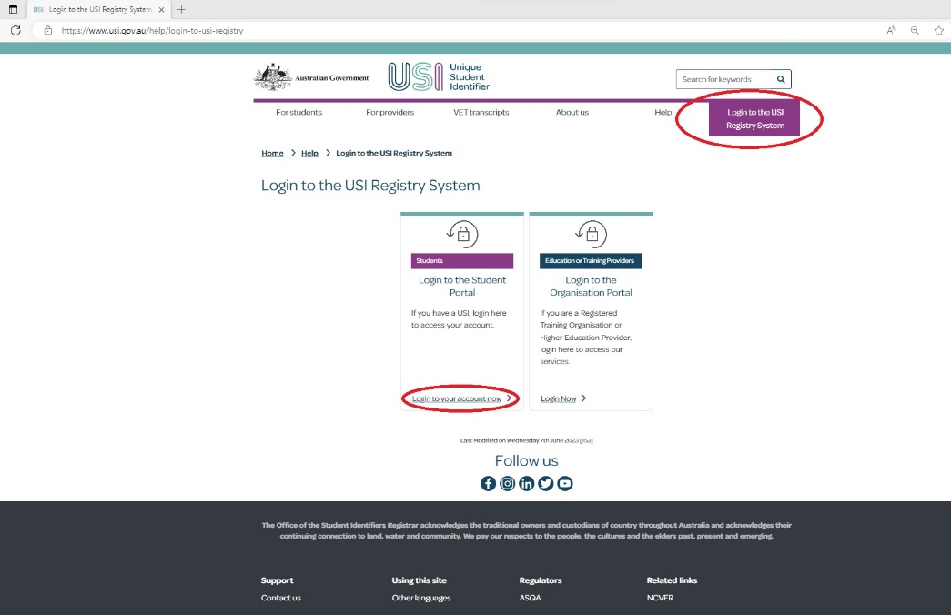

Step 3: Enter your USI/Email address and password to login.
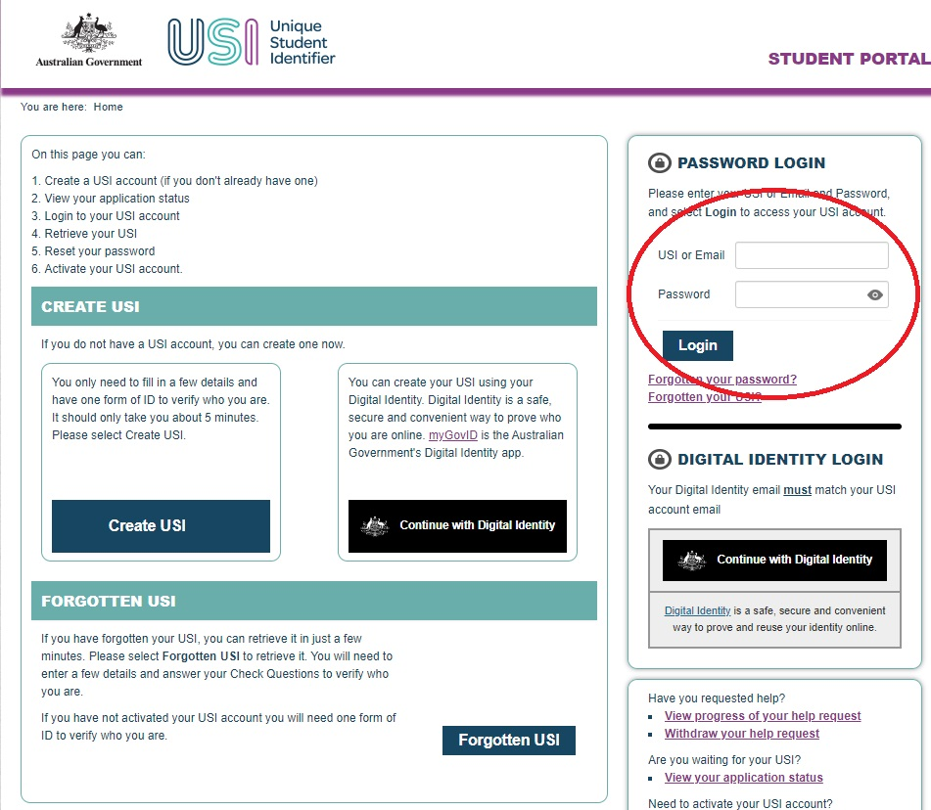
Step 4: Click on “Provide your USI” button.
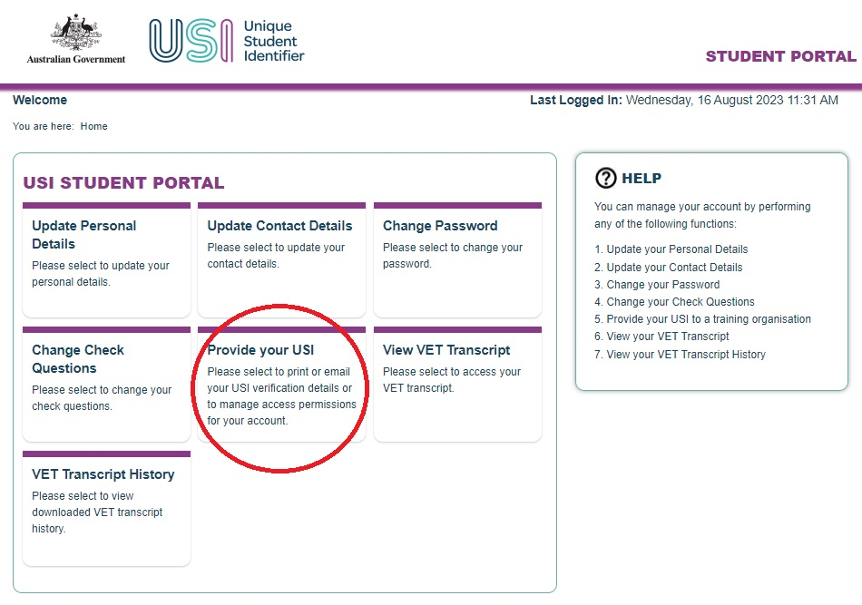
Step 5: click on “Add Organisation” button under “SET UP ACCESS TO YOUR USI ACCOUNT/PERMISSIONS” at the bottom of the screen.
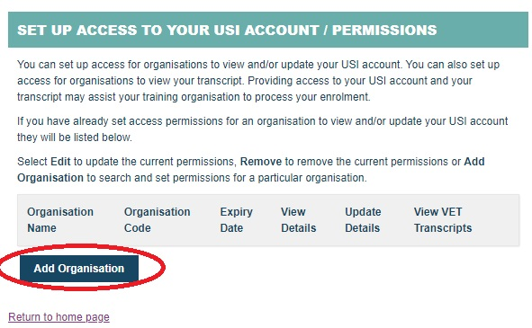
Step 6: In “SEARCH DETAILS” section, please enter below details:
Organisation Code: 60142
Organisation Name: TasTAFE
Click “Search” and in “SEARCH RESULTS” section, click “Add”.
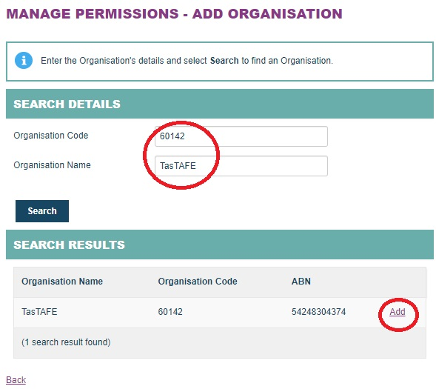
Step 7: In “MANAGE PERMISSIONS – SET PERMISSIONS” section”:
- Tick box for “View Transcript” and “View Details”
- Select “Expiry Date” to “2 Years”
- Click “Save”.
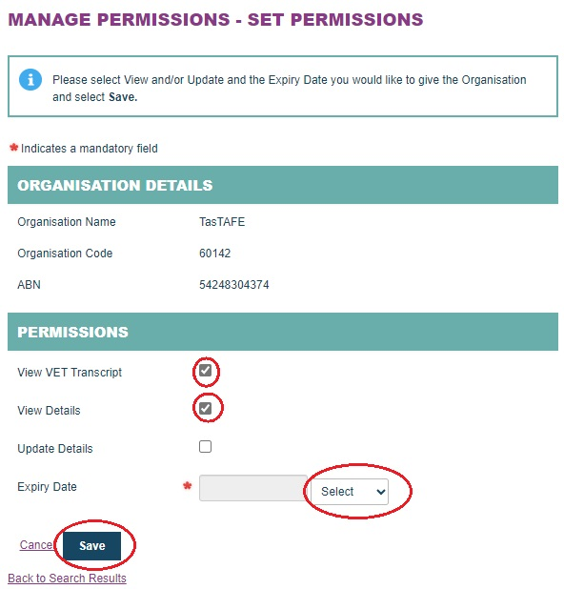
You can now see that you have successfully added “TasTAFE” into this “SET UP ACCESS TO YOUR USI ACCOUNT/PERMISSIONS” now.
