Table of Contents

[Logging onto Canvas 2](#_Toc199999872)

[Your Username and Password 2](#_Toc199999873)

[When you log on for the first time 3](#_Toc199999874)

[Verification Step 5](#_Toc199999875)

[Your Canvas Account 9](#_Toc199999876)

[How do I add contact methods to receive Canvas course notifications? 10](#_Toc199999877)

[Your TasTAFE Email account 11](#_Toc199999878)

[Office 365 for Students 12](#_Toc199999879)

[Canvas Help 12](#_Toc199999880)

[IOS and Android Student Apps 13](#_Toc199999881)

[About the Rich Content Editor 16](#_Toc199999882)

[About Discussions 17](#_Toc199999883)

[Canvas Calendar 19](#_Toc199999884)

[Kaltura Video 21](#_Toc199999885)

[Uploading media into Canvas 23](#_Toc199999886)

[How do I upload a file to an Assignment? 24](#_Toc199999887)

[Office 365 25](#_Toc199999888)

[Dropbox 26](#_Toc199999889)

[Google Drive 27](#_Toc199999890)

[How do I know if my Assignment has been submitted? 28](#_Toc199999891)

[View Rubric 29](#_Toc199999892)

[Finding new comments, if they are added 30](#_Toc199999893)

[Quizzes 32](#_Toc199999894)

[How to re-submit a Quiz? 34](#_Toc199999895)

[Marks 35](#_Toc199999896)

[Feedback from teachers 37](#_Toc199999897)

[Contact your teacher 38](#_Toc199999898)

[Help 38](#_Toc199999899)

[Inbox 39](#_Toc199999900)

[Discussions 39](#_Toc199999901)

## Logging onto Canvas

For the best user experience, log in using the latest Google Chrome or Microsoft Edge web browser. Browser and computer requirements are available at [Canvas Community](https://community.canvaslms.com/t5/Canvas-Basics-Guide/What-are-the-browser-and-computer-requirements-for-Canvas/ta-p/66).

* Access Canvas anywhere you have an internet connection a <https://canvas.tastafe.tas.edu.au/>
* Canvas can also be accessed via the TasTAFE website <https://www.tastafe.tas.edu.au/student-login>
* View the Canvas Guides [Canvas Guides by mobile apps on Canvas Community](https://community.canvaslms.com/t5/Canvas-Mobile-Users/gh-p/mobile)

### Your Username and Password

Please check your TasTAFE Student account details email.

**Logging on for the first time only**

Use these instructions as well if you have forgotten your password

**Username**: Your username is: [firstname.lastname.00@student.tafe.tas.edu.au](mailto:firstname.lastname.00@education.tas.edu.au)

This is also your TasTAFE email address.

\*Username exceptions apply:

* If you provided a 'preferred name' at enrolment, use that as your 'firstname'
* A long or hyphenated name, may be shortened
* You may have a different number than '00' in your username.

**Password**

You will need to set your password when logging in for the first time. Passwords need to be a **minimum** of **8 characters;** are case sensitive**;** contain **one** number **or** symbol.

\*Ask your teacher or a library staff member for assistance if you are unable to log in.

## When you log on for the first time

**On Campus**

* When you log in on a TasTAFE PC or log in on your personal device for the first time, you will set your password.

[firstname.lastname.00@student.tafe.tas.edu.au](mailto:firstname.lastname.00@education.tas.edu.au)and your TasTAFE Password.

* Your new password should be between 8-256 characters, containing **one** number or symbol. Passwords are case sensitive.

**Off Campus**

* Access Canvas anywhere you have an internet connection at <https://canvas.tastafe.tas.edu.au/>
* You must change your default password before you proceed. See the steps below. Enter your supplied username details and click **Next**

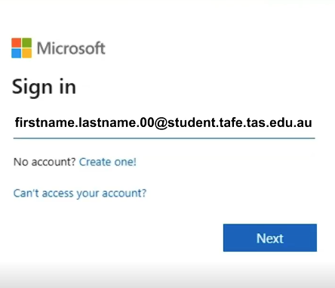

Choose **forgot my password**

forgot your password screen


 Enter the Captcha details into the field provided and click **next**

captcha details screen
, Picture

### **Verification Step**

Enter an alternate email address, **or** a mobile phone number for the verification code to be sent to.

 Choose **next**

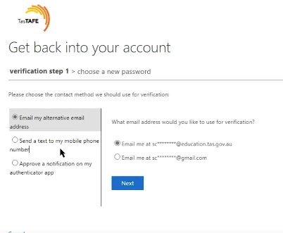

Enter the code sent to your mobile or alternate email address, and choose **next**

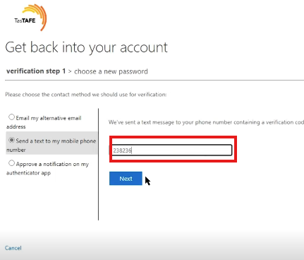

Enter your password into the **Enter new password** field, and the **Confirm new password** fields. Click **Finish**

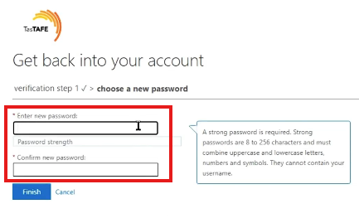

Upon clicking **Finish** you will be prompted to return to the login screen

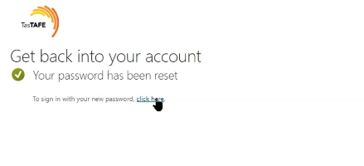

 You can then enter your username and newly created password

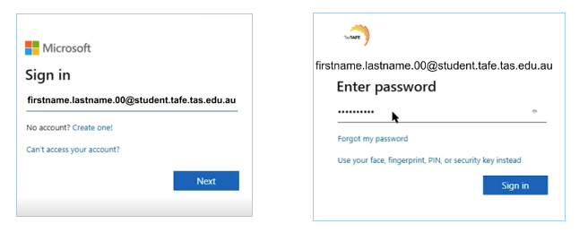

At the next screen answer, tick the **Don’t show this again** option **yes** to the stay signed in.

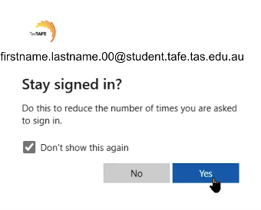

You will then see your Canvas dashboard

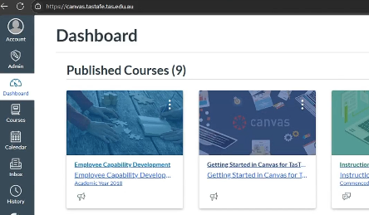

## Your Canvas Account

**Notifications in Canvas**

It is recommended you set up your Canvas notifications as shown below

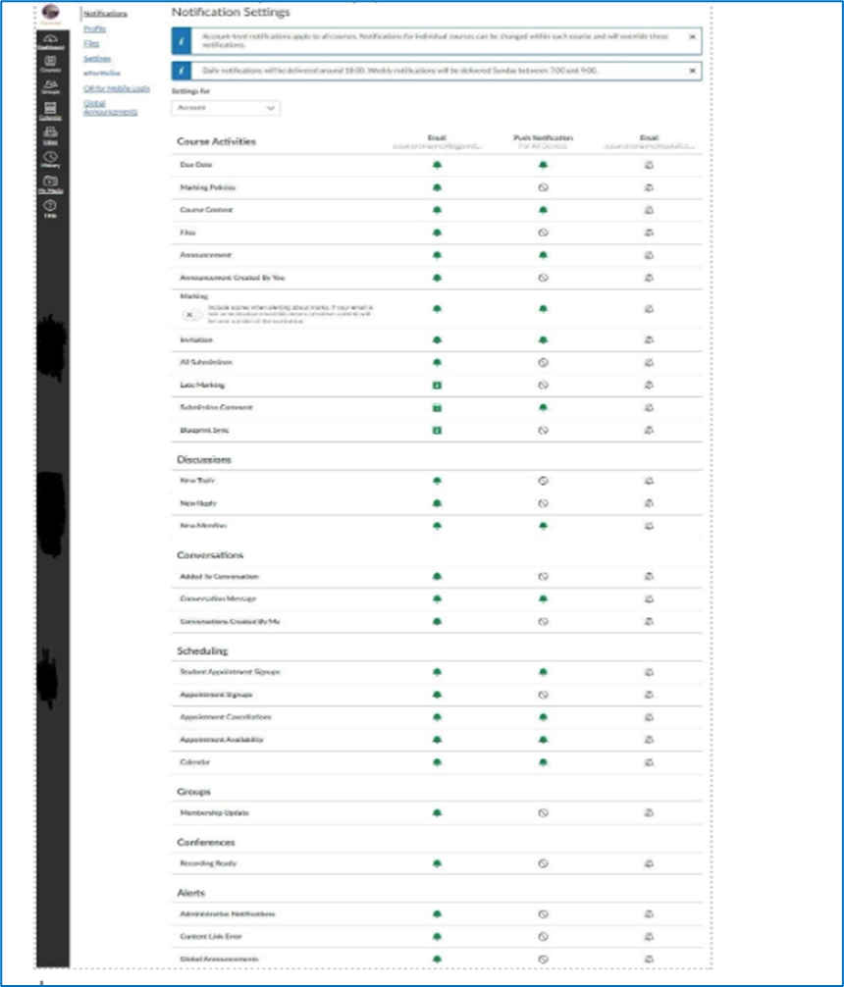

## How do I add contact methods to receive Canvas course notifications?

By default, you will only receive notifications to your TasTAFE student email address.

You can manage notifications for a single course on the Course Notification Settings page.

Course notification settings only apply to the course in which they are set. To receive course notifications, you must first set your [Canvas notification preferences](https://community.canvaslms.com/t5/Student-Guide/How-do-I-set-my-Canvas-notification-preferences-as-a-student/ta-p/434).

Canvas supports notification through email only.

**Notifications Video**

View a [video about Notification Preferences.](https://community.canvaslms.com/t5/Video-Guide/Notification-Preferences-All-Users/ta-p/383690)

**Add Ways to Contact**

* In Global Navigation click the Account link
* Click the Settings link

In the Ways to Contact sidebar, your account displays the [default email](https://community.canvaslms.com/docs/DOC-10368-4152719740) associated with your account (TasTAFE email)

**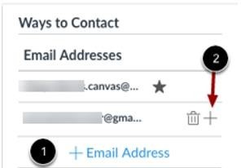**

**Add an additional email address.**

However, if you want to [add an additional email address](https://community.canvaslms.com/docs/DOC-10054-4152719739), click the **Add Email Address** link [1]

Please note you may access your

TasTAFE email via <https://outlook.office.com/mail>

## Your TasTAFE Email account

Upon enrolment you are automatically allocated a TasTAFE student email account. By default, you will receive Canvas notifications to your TasTAFE email address. Please refer to page 9 of this guide for information about Notifications in Canvas.

**Your email address will be your TasTAFE username**

[firstname.lastname.00@student.tafe.tas.edu.au](mailto:firstname.lastname.00@education.tas.edu.au)

**Log into your TasTAFE Email Account**

Via the TasTAFE website

1. Open the TasTAFE website [www.tastafe.tas.edu.au](http://www.tastafe.tas.edu.au/)

1. Look under: Student Connect/Login > Student Login > Student Email Login [https://www.tastafe.tas.edu.au/student-login](https://www.tastafe.tas.edu.au/student-login" \t "_blank)

**Via any web browser**

You can access your TasTAFE email account anywhere you have an internet connection via a web browser at <https://outlook.office.com/mail>

1. Enter your TasTAFE login details
2. Username: [firstname.lastname.00@student.tafe.tas.edu.au](mailto:firstname.lastname.00@education.tas.edu.au)
3. Password: enter your TasTAFE password

If you receive an ‘incorrect username or password’ error, follow the password reset instructions at the beginning of the document.

## Office 365 for Students

For Home and your own Devices

Would you like to be able to use the same Microsoft Office products at home or when you are off campus or on your mobile devices??

**TasTAFE is now licensed to offer Office 365 to students:**

* + - Up to 5 copies of Office at home for Windows or Mac
    - Up to 5 Copies for mobile devices

**Download Office 365 at home**

Go to: [Office.com](https://www.office.com/)

1. Log in with your TasTAFE username and password, this is in the following format:

f[irstname.lastname.00@student.tafe.tas.edu.au](mailto:firstname.lastname.00@education.tas.edu.au) 

1. Select ‘Install now’ and follow the prompts

## Canvas Help icon and optionsCanvas Help

Click on the **Help** icon. The last icon on the left-hand side

Then choose a link from the extensive menu of help topics

**Search the Canvas Guides**

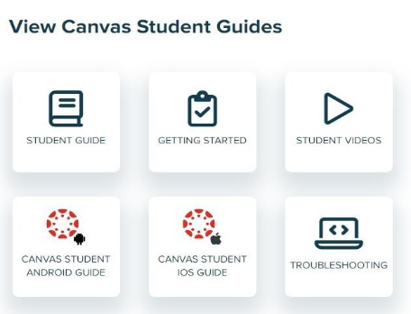

## IOS and Android Student Apps

Canvas has both IOS and Android apps available Review each app below for your device.

**iOS Canvas Student App – Download and login – page 14**

The **Canvas Student app** is the mobile version of Canvas that helps you stay current with your courses anywhere you go.

Download the **Canvas Student app** for iOS devices from the App Store.

\*Having trouble with the Canvas App use your mobile device web browser instead [https://canvas.tastafe.tas.edu.au](https://canvas.tastafe.tas.edu.au/)

Online guide: Canvas Student iOS

**Android Canvas App – Download and login – page 15**

The **Canvas Student app** is the mobile version of Canvas that helps you stay current with your courses anywhere you go.

Download the **Canvas Student app** for Android devices from the Play Store. See below:

\*Having trouble with the Canvas App – use your mobile device web browser instead [https://canvas.tastafe.tas.edu.au](https://canvas.tastafe.tas.edu.au/)

**Online guide:** **IOS App Guide**

|  |  |
| --- | --- |
| 1) Open your iOS device and tap the **App Store** icon. | student app icon8) You can open the app on your iOS home screen by tapping the Canvas Student icon |
| 2) In phone devices, tap the **Search icon** at the bottom of the screen.  In tablet devices, tap the **Search field** at the top of the App Store | 9) Tap the Find my school button  The Canvas app find my school icon |
| 3) In the search field, type **Canvas Student** in the search field. Tap the full name when it appears. | 10) Type **TasTAFE** |
| 4)Tap the **Get** button. | 11) When TasTAFE appears in the search list, Click **Go** or tap the name.  If the app cannot find your school, you can use TasTAFE’s Canvas URL to log in  <https://canvas.tastafe.tas.edu.au> |
| 5) Tap the **Install** button.  **Note:** iTunes may ask for your iTunes password to download the app. | 12) Enter log in details  **Username**: f[irstname.lastname.00@student.tafe.tas.edu.au](mailto:firstname.lastname.00@education.tas.edu.au)  **Password:**  Your TasTAFE password |
| 6) When the app has downloaded and installed onto your iOS device, you can access the app immediately by tapping the **Open** button | 13) Click **Sign in** |
| 7) If you would like to receive Canvas notifications click the **Allow** button | 14) View the Canvas Dashboard |

**Android App Guide**

|  |  |
| --- | --- |
| play store icon1) Open your Android device and tap the **play Store** icon. | find my school logo7) Tap the Find my school button |
| 2) Tap **Search field** at the top of the play store | 8) Type **TasTAFE** |
| 3) In the search field, type **Canvas Student** in the search field. Tap the full name when it appears. | 9) When TasTAFE appears in the search list, Click **Go** or tap the name.  If the app cannot find your school, you can use TasTAFE’s Canvas URL to log in  <https://canvas.tastafe.tas.edu.au> |
| 4)Tap the **Install** button.  Image of Play Store search results, Picture | 10) Enter log in details  **Username**: f[irstname.lastname.00@student.tafe.tas.edu.au](mailto:firstname.lastname.00@education.tas.edu.au)  **Password:**  Your TasTAFE password |
| Before the app downloads it will ask for access to items on your device. , Grouped object5) Before the app downloads, the Canvas app will ask for access to items on your device.  You can click the grey  downward arrow to read more about each item. | 11) Click **Sign in** |
| 6) Tap **Accep**t to allow the items listed to work with the Canvas app | 13) View Canvas Dashboard |

## About the Rich Content Editor

The Rich Content Editor allows you to add and format content for Assignments, Discussions and Quizzes.

Format Text and upload supported media types:

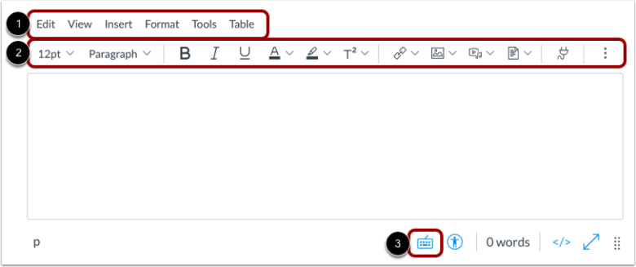

The menu bar will display above the Rich Content Editor [1]. The menu bar includes the same tools as found in the toolbar [2], but in a format that is easier to navigate with a keyboard.

To view a window with a list of keyboard navigation shortcuts, click the **Keyboard** icon **[3]**

Further information about each of the menu bar options mentioned above can found within the [Canvas Community Guide](https://community.canvaslms.com/t5/Student-Guide/How-do-I-use-the-menubar-in-the-New-Rich-Content-Editor-as-a/ta-p/357)

Text editing includes font size, bold, italic, underline, text colour and background colour using the icons.

You can format headings, indent or align content. Insert tables, bullets, numbered lists, maths equations and media including YouTube videos and images.

## About Discussions

Discussion allows both teachers and students to contribute to discussion topics. Students can participate in a conversation with an entire class or group.

Discussions can be an assignment or simply serve as a forum for topical and current events.

Discussion topics can be a focused or threaded discussion. Focused discussions are short-lived interactions, while threaded discussions allow replies within replies  and may last for a longer period.

**NOTE**: your instructor may choose to find the Discussions link in the course Navigation.

If the Discussions link is not available, you can still access discussions through other areas of Canvas.

**Open Discussions**

In Course Navigation, click the Discussions link.

discussions


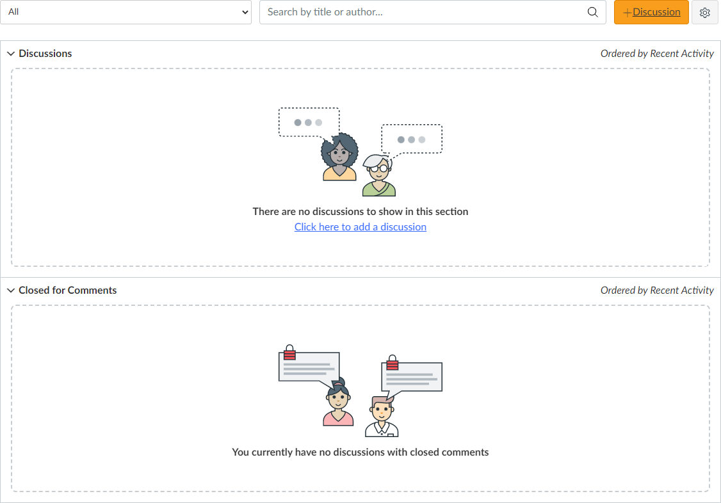

**Discussions are organized into three main areas.**

Discussions [1]: These are current discussions within the course. Discussions are ordered by most recent activity. You will only see this section heading if there are discussions within this section.

Pinned Discussions [2]: These are discussions that your instructor wants you to pay specific attention to and will appear at the top of the Discussions page. You will only see this section heading if there are discussions within this section as designated by your instructor.

Closed for Comments [3]: These discussions have been manually closed for comments, or the discussion is past the available from/until date. These are discussions that are only available in a read-only state and are ordered by most recent activity. You will always see this section heading, even if there are no discussions within this section.

## Canvas Calendar

The Calendar is a great way to view everything you have to do for all your courses in one place. You can view calendar events by day, week, month, or agenda list.

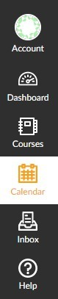The calendar also includes access to the Scheduler, which is an optional scheduling tool in Canvas.

In Global Navigation, click the link

**Calendar**

The Calendar displays everything you are enrolled in since the Calendar spans across all courses. As displayed below, in the navigation bar, you can choose to view the calendar in Week, Month or Agenda view.

The view dictates the style of calendar window **(1)**

By default, the calendar appears in **Month view (2)**

The sidebar **(3)** shows a quick-view calendar, just list of your courses and groups

A screenshot of the Canvas calendar calendar



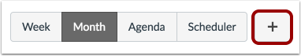**Add Calendar Items**

Each calendar view shows any assignments or events that have been added to the calendar. Events can be added at any time in the navigation bar by clicking

the **Add** button.

You can [add assignments](https://community.canvaslms.com/docs/DOC-10192-415254671) and [add course events](https://community.canvaslms.com/docs/DOC-10043-415241296), and all users can [add personal](https://community.canvaslms.com/docs/DOC-10315-415241985) [events.](https://community.canvaslms.com/docs/DOC-10315-415241985)

## Kaltura Video

Kaltura Video enables you to view, record, upload, publish, search, and share videos directly from Canvas. Kaltura is accessed through Canvas.

You will be able to upload videos into assessments, quizzes, discussions directly in your Canvas course.

**Please note** deleted items **cannot** be retrieved.

Nor can Media be accessed once your course is finished.

We recommend that you download any items you wish to keep before your course ends.

Kaltura does not work with the mobile Canvas Apps. To use Kaltura on your mobile device you will need to open Canvas via a supported web browser.

You will need to authorise the first time you log on to Kaltura.

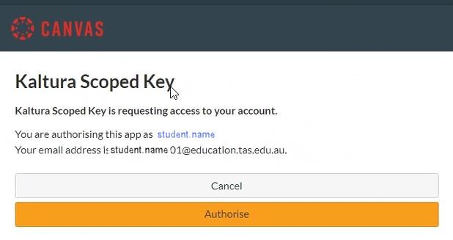

There are two parts to Kaltura

1. **MyMedia** is your personal media space and holds the media that you have uploaded or created in Kaltura. Teachers and students cannot access your MyMedia.
2. **Course Gallery** is the media uploaded by your teachers that is available in your Canvas Course. Course Gallery is accessed from within your Canvas course using the course menu.

**MyMedia** is accessed from the Global Canvas Navigation Menu and is where you can upload and manage your videos.

Click on **MyMedia**, select **Add New**, and choose **Media Upload**.

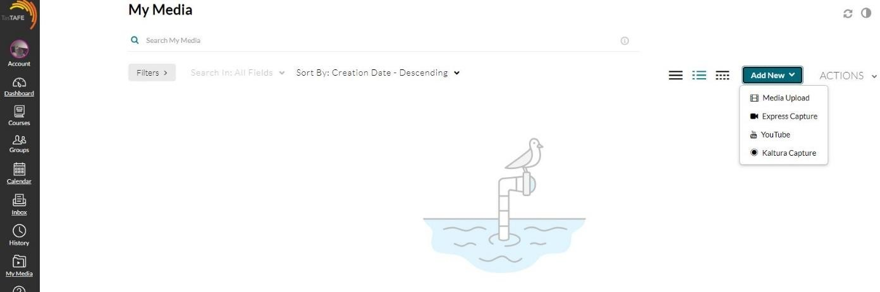

2

1

Make sure you give your video a relevant name. We recommend your first name, last name, subject matter, or task name, follow the guidelines given in your course.

A screenshot of a phone

kaltura my media steps
When your video is uploaded it will appear in MyMedia and can be edited using the edit icon (1) on the far right. Then launch (2) editor to trim (3).

**Remember** MyMedia can only be seen by you!

You will need to upload it into Canvas before your teacher can view your video

### **Uploading media into Canvas**

Media is uploaded into Canvas by the Rich Content Editor [Page 16].

When the Kaltura icon Kaltura Icon is selected, the Kaltura Media window appears, you can choose from one of two options:

**Option 1**: Add New, **or**

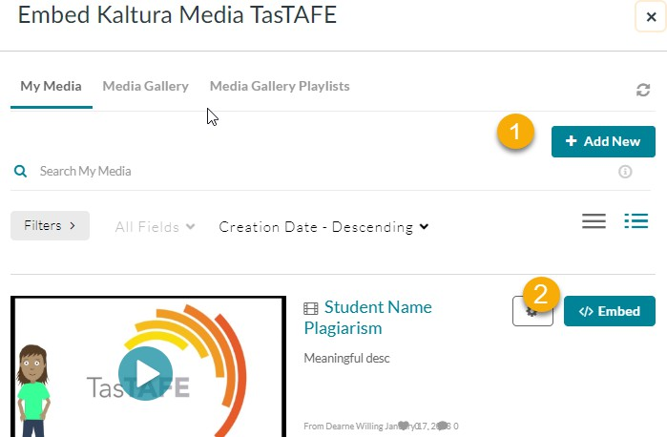**Option 2**: embed from your existing content.

After selecting Option 1 or 2 you must choose 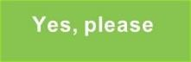 before your media will become visible to your teacher.

**Important:** When uploading media to Assignments you must select the Text submission type which displays the Rich Content Editor.

Follow the prompts on the Kaltura Media window, select either Option 1 or 2 as above.

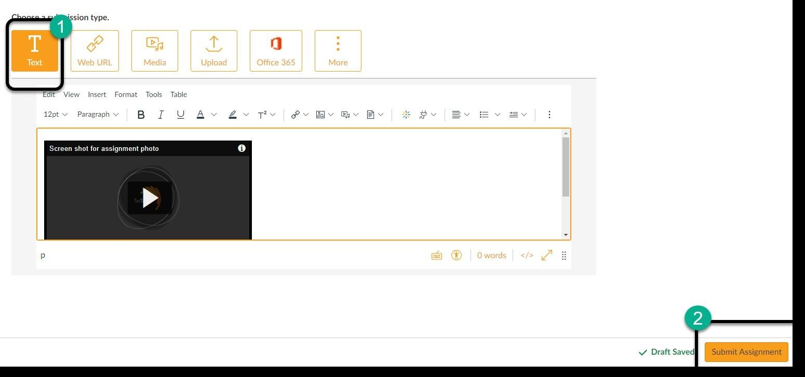After selecting  the Canvas Submit button becomes available

## How do I upload a file to an Assignment?

You can submit online Assignments in Canvas using several submission types. Not all file types may be available for your assignment, depending on the assignment submission type set by your teacher.

Any attachments added as part of a marked assignment submission are also copied to your user files.

1. Open the Assignment (Assessment)
2. Read the Student Instructions and How to submit your assessment
3. Select a submission type – see options below

**Canvas will not accept file uploads larger than 500 MB.** Upload large files to Canvas via Office 365, Dropbox or Google Drive, see following pages or instructions

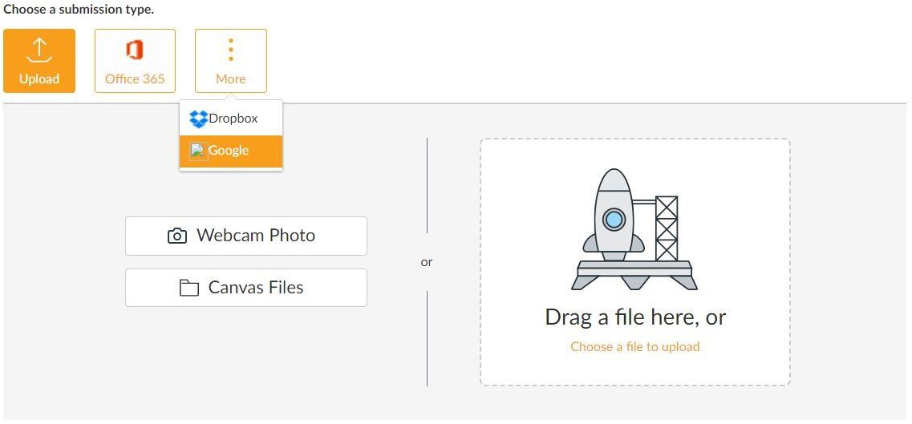

## Office 365

Office 365 is available free to every enrolled TasTAFE student.

Canvas accepts Microsoft Word, Microsoft PowerPoint, Microsoft Excel, and PDF types.

Files uploaded from Office 365 are uploaded into your Canvas user files submissions folder.

Canvas will require you to authorize access to your OneDrive account.

When Office 365 files are uploaded as a submission, later changes made to the file in OneDrive will not be updated in the submission.

**Note:** In Office 365 assignments, you can only submit one file for your submission.

###### **Instructions to upload from Office 365**

1. Open the Assignment
2. Click Submit Assignment top right
3. Choose Office 365 from file submission options
4. Click Log In to log in to your Office 365 account to access your files
5. Log In to Office 365
6. 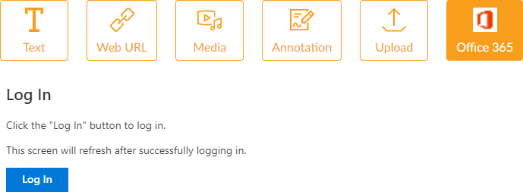Find and Select a File
7. Click Attach File
8. Add a Comment - if you wish
9. Click Submit Assignment

## Dropbox

Canvas accepts Dropbox files for assignment submissions.

When Dropbox files are uploaded as a submission, the files convert to their Microsoft counterpart file types and appear in the submission as respective Word, Excel, or PowerPoint files.

This conversion essentially preserves the submission in its current state; any changes made to the file in Dropbox will not be updated in the submission.

**Note:** In Dropbox assignments, you can only submit one file for your submission.

###### **Instructions to upload from Dropbox**

1. Open the Assignment
2. Click Submit Assignment (top right)
3. Choose Dropbox option for file submission by clicking on more
4. Click the blue ‘Select File to Retrieve’ link
5. A new window appears for you to sign into your Dropbox account to access your files
6. You may need to solve a puzzle or two to verify your account
7. 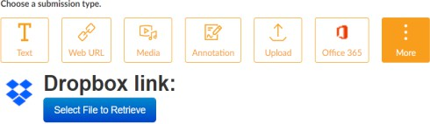Select the file to submit
8. Click Choose
9. Add a Comment if you like
10. Click Submit Assignment

## Google Drive

Canvas accepts Google Doc, Sheet, and Slide files. You can also upload any uploaded Word, Excel, PowerPoint, and PDF files not converted to Google Docs formatting.

When Google Drive files are uploaded as a submission, the files convert to their Microsoft counterpart file types and appear in the submission as respective Word, Excel, or PowerPoint files.

This conversion essentially preserves the submission in its current state; any changes made to the file in Google Drive will not be updated in the submission.

**Note:** In Google Drive assignments, you can only submit one file for your submission. [More info](https://community.canvaslms.com/docs/DOC-10472-4212344077)

###### **Instructions to upload from Drive**

1. Open the Assignment
2. Click Submit Assignment (top right)
3. 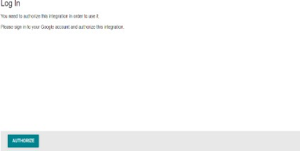Choose Google Drive from file submission options
4. Click Authorise to log into your Google Drive account
5. Sign into your Google account
6. Click Allow when the Google Drive LTI by Canvas appears
7. Select a file
8. Click Submit
9. Add a Comment if you like
10. Click Submit Assignment

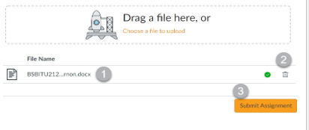Your file displays as a draft submission [1].

To delete the file, click the

Delete icon [2]

Submit Assignment button [3]

## How do I know if my Assignment has been submitted?

When you submit an assessment the Progress Tracker displays the assignment submission status. A successfully submitted assignment displays a Submitted status

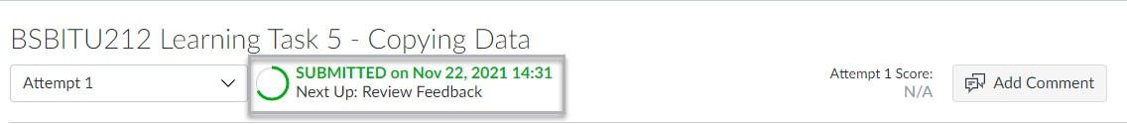

**Resubmitting Assignments**

* Read the Assignment Comments, complete the further requirements
* Try again ButtonClick the Try Again button.
* Choose a submission type
* **Drag a file here** or **choose a file to upload** [1]
* You can cancel your submission at any time [2]
* Click **Submit**

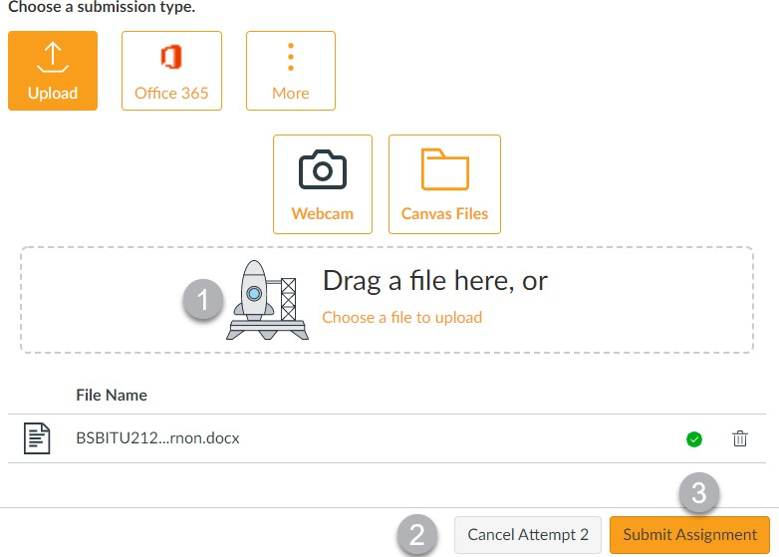

Once the assignment has been submitted the Progress Tracker displays the assignment submission status. A successfully submitted assignment displays a Submitted status [1].

The attempts have been updated to **Attempt 2** [2]

## View Rubric

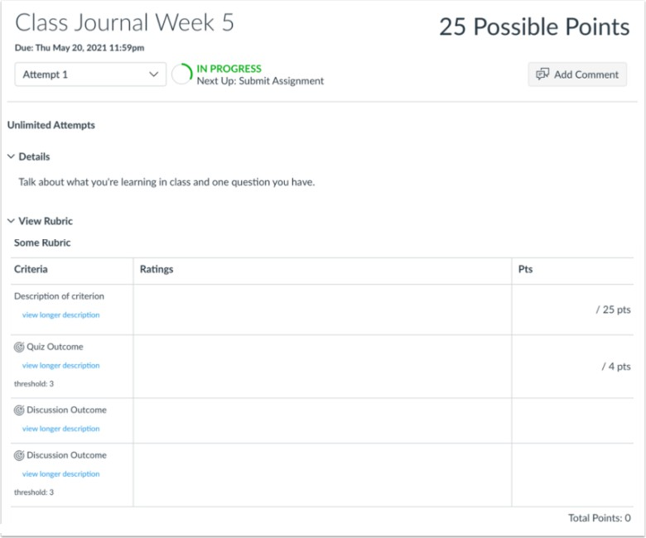Open assignment. If an assignment has a rubric added to the assignment the **View Rubric** section automatically expands to display

### **Finding new comments, if they are added**

If a new comment is added to an assignment or to a rubric, a blue dot icon will display on the comment icon to the right of the assessment task name, click on the feedback window to view the comment.

A screenshot of Marks


**Where do I find my Assignment submissions (file uploads only)?**

A screenshot of a login screen


You can view all the files you have uploaded to your assignments from the Files section in your Account.

1. Open Account from the Navigation Panel.
2. Open Files
3. Open the Submissions folder (Click on My Files to expand the folders if necessary).
4. Select the course you would like to view your file uploads for.
5. The right-hand side will show the list of files for the course selected.

A screenshot of file uploads


To view and download to your computer: click on the file name or place your cursor over the file and click the three dots at the right-hand side.

## Quizzes

**Quiz options**

In Quizzes students can:

* Access a calculator, both basic and scientific,
* Pin questions to come back to later,
* Experience new styles of questions and answers,
* BOLA: Build On Last Attempt.

With the Build on Last Attempt feature you will be asked to reattempt the incorrectly answered questions, instead of taking the entire quiz again.

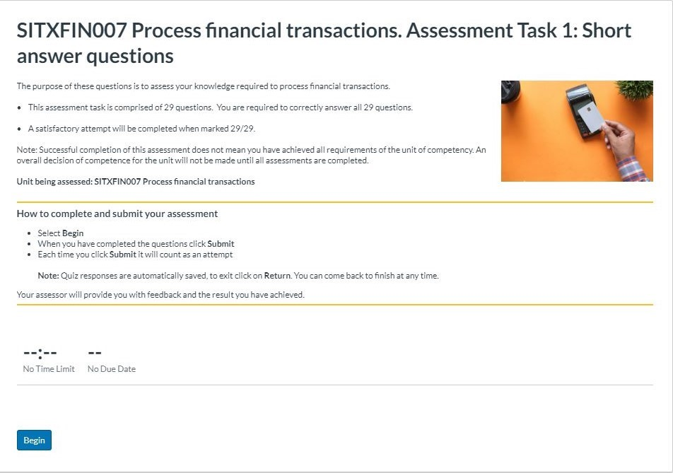

**How do I complete a Quiz?**

1. **Read** the Quiz **Instructions**
2. Take note of the number of questions, if a time limit has been set and allowed attempts.
3. Click **Begin** button

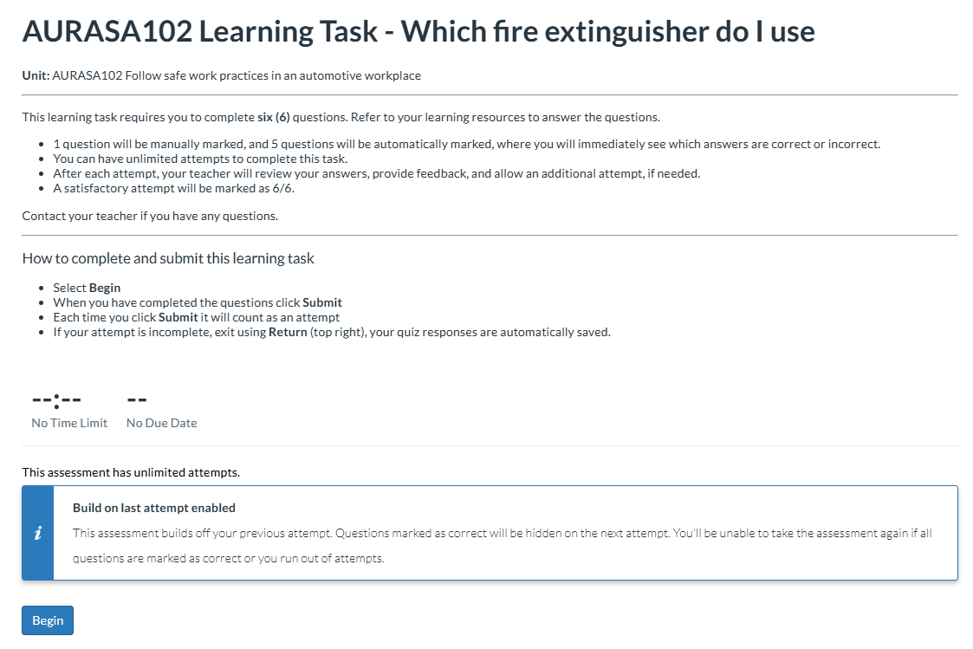

### **How to re-submit a Quiz?**

Read the **Assignment Comments** and only complete the questions you are directed to do so. When you click Submit Canvas will say you have missed the questions e.g., a, b and c, you must click **Submit** anyway.

1. Read feedback from your teacher under **Marks** in the Course Menu
2. **Open** the Quiz
3. Review the **Last Attempt Details** (top right)
4. Review the previous Quiz attempt – See under **Attempt History** e.g. ‘Attempt 1’
5. Click **Take the Quiz Again** to begin your next attempt.

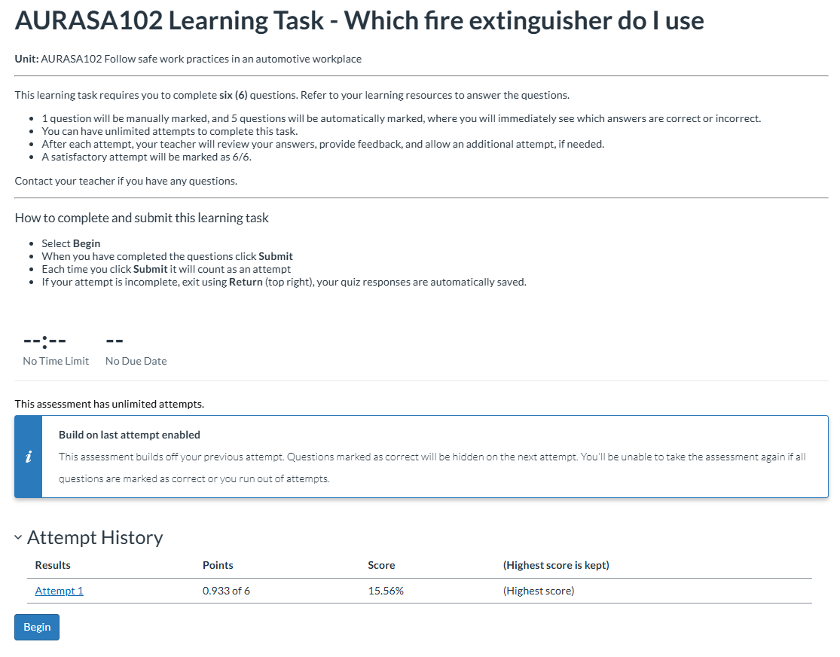

## 

## Marks

**How will I know when an Assignment or Quiz has been marked?**

When your teacher has marked an assessment, your **Dashboard** will display the assessment name and comment under **To Do list** > **Recent Feedback** – top right of the **Dashboard**.

Click the Assessment name under **Recent Feedback** to review the assessment mark and feedback from your teacher.

Alternatively, assessment feedback can be displayed under **Marks** in the course menu.

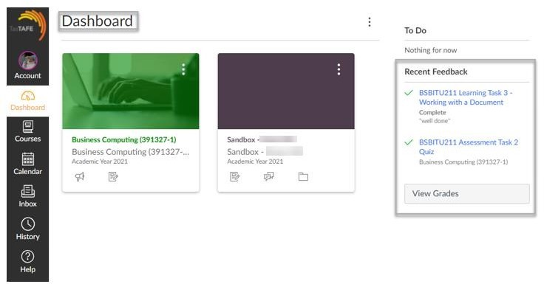

A screenshot of Course homepage displaying marks 


**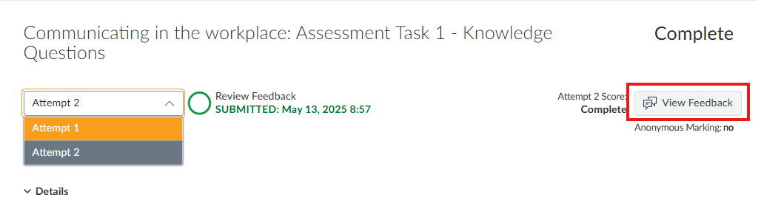**

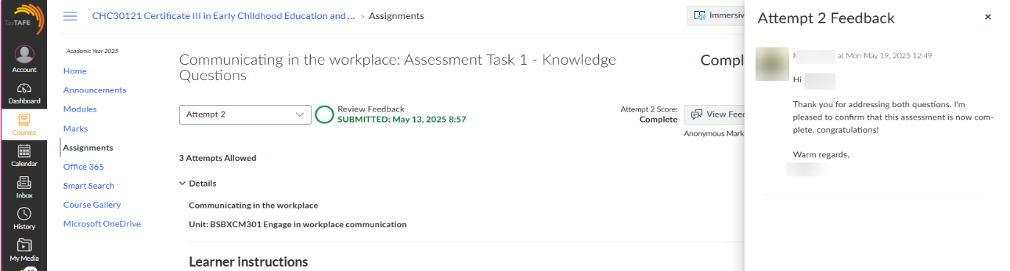

If you have submitted multiple attempts, you can move between both attempts

## Feedback from teachers

When your teacher has provided feedback on an assessment, your **Dashboard** will display the assessment name and comment under **Recent Feedback** - top right of the **Dashboard** (see page 35).

If you click on the assessment task name under Recent Feedback you will see teacher feedback (in the form of a message, a file upload or an audio/video comment). There is space for you to return comment via the comment box, attach a file, or audio/video comment. Ensure to **Save** the return comment

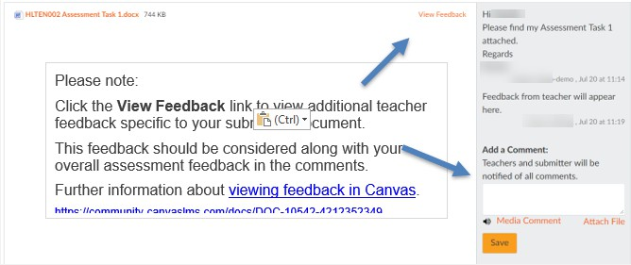

A screenshot of Teacher's feedback/comment on assessments
If you click on **Marks** in the course navigation menu or **View Grades** in the **Dashboard,** click on the comment icon to the right of the assessment task name to review feedback from your teacher



## Contact your teacher

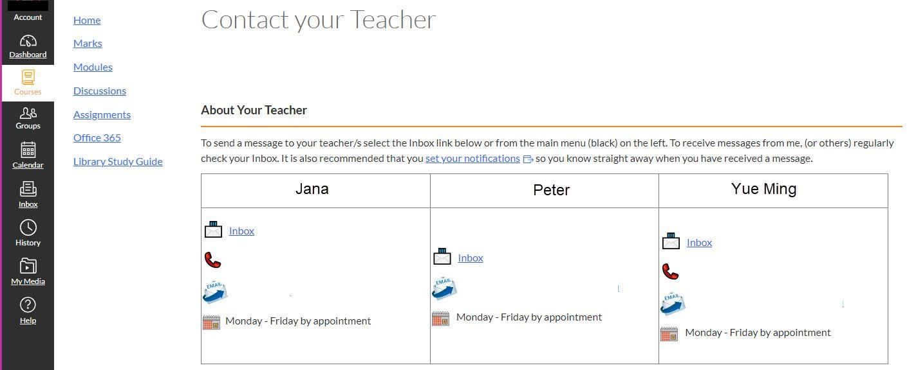If you would like to contact your teacher in Canvas you can choose from the following options: **Contact your teacher | Help | Inbox | Discussions**

## A screenshot of a Help menuHelp

* Click on **Help** from the **Canvas navigation menu**
* Click on **Ask Your Teacher a Question,** choose your course and type your message.
* Click **Send Message**

## Inbox

Click on **Inbox** link on from the **Canvas navigation menu** to email your teacher. Click the **Compose new message** link (pencil) to compose an email

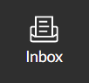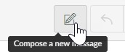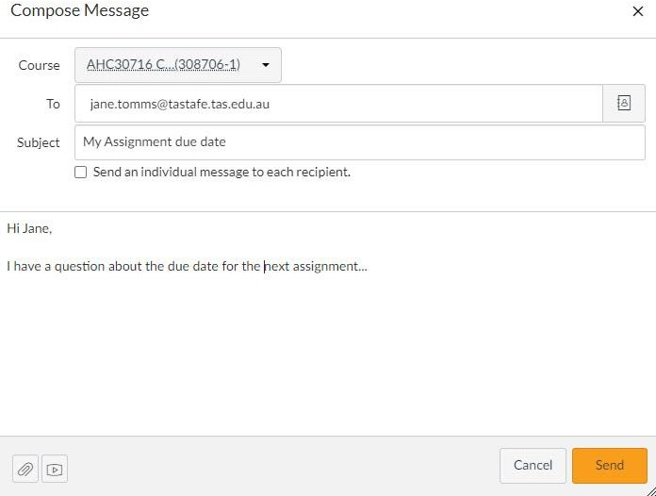

## Discussions

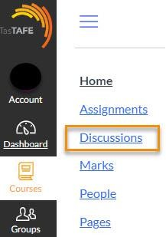

You may also communicate with teachers and other students via the **Discussions** link on the Course Navigation menu