TasTAFE

Diploma of Nursing

Conceptual Framework

Nurses promote wellness, quality of life and dying with dignity.
They achieve this through building therapeutic relationships with clients’ and putting them at the centre of each episode of care. Nurses care for each of their clients’ holistically, recognising that each individual has their own set of values, beliefs and knowledge that will influence their goals and experiences within the healthcare system. Nurses are held in high regard as a profession and therefore strive to maintain professional standards of practice to uphold public expectation of the profession (Nursing and Midwifery Board of Australia 2017).
Just as nurses have a person centred approach to care, so too does TasTAFE have a student centred approach to nursing education. Our teachers are passionate about nursing as a profession and recognise that each student has their own life experiences, educational experiences and values which will influence their nursing education journey and inform their nursing practice.
We achieve a student centred approach by providing face-to-face teaching, supplemented by online learning, and maintaining small class sizes. From the point of enrolment through to graduation, students will have contact with teachers and support staff who know them by name and celebrate student achievement.
The Diploma of Nursing program requires graduates to develop both technical and theoretical knowledge required to provide nursing care for people across different stages of life in a range of settings across the health sector (Industry Skills Council 2015). Graduates of the Diploma of Nursing program require well developed cognitive, technical and communication skills, and have the ability to apply these skills in dynamic and changing environments (Australian Qualifications Framework Council 2013).
A modern constructivist framework underpins the TasTAFE Diploma of nursing program. Our teachers are student focussed and consider previous learning to be a foundation upon which to build and expand knowledge (Peters 2000). Our constructivist andragogy is informed by theorists such as Lev Vygotsky, Jerome Bruner, David Ausubel.
In order to develop students throughout the Diploma of Nursing program, TasTAFE scaffolds students learning experiences using a spiral curriculum structure. The spiral curriculum approach (Figure 1) allows students to construct learning through repeated experience, practice and critical examination of concepts and technical skills that increase in complexity in each revisitation (Ross, Noone, Luce and Sideras 2009). For example, at the base of the spiral students may be introduced to evidenced-based approaches to controlling the spread of infection such as handwashing.
As learning progresses, students will continuously revisit infection control measures through participation in simulated client care scenarios. Finally, students will be able to demonstrate their role and responsibilities in relation to preventing and controlling healthcare-associated infection through participation in complex care scenarios and identifying relevant standards of practice.

Figure 1. The spiral curriculum (© 2019 TasTAFE)

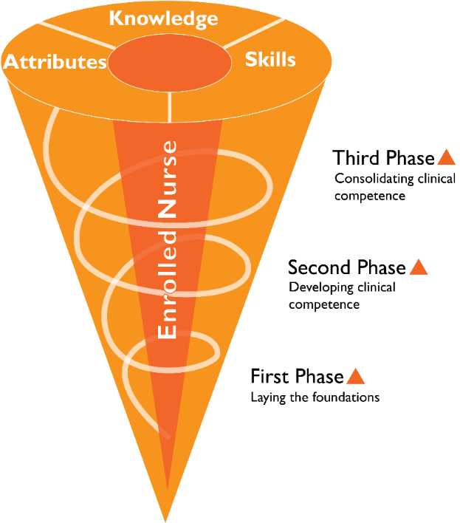

For students to be able to achieve the complexity of knowledge and skills required, the spiral curriculum is dependent not only on repetition and practice, but upon critical examination of these experiences.
Throughout the Diploma of Nursing teachers model and teach students to become critically reflective practitioners through the use of the clinical reasoning cycle (Figure 2) (Levett-Jones ed. 2013).
The clinical reasoning cycle is a process by which nurses collect and process information in order to understand a situation so they can plan how to address problems, whilst encouraging them to evaluate, reflect and learn from the process (Levett-Jones, Hoffman, Dempsey, Jeong, & Noble 2012).

The clinical reasoning cycle
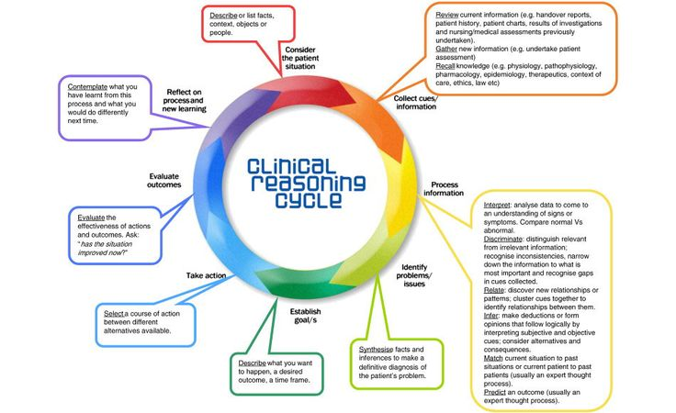
Figure 2. The clinical reasoning cycle (Levett-Jones 3013).

The spiral curriculum represents the structure of the Diploma of Nursing program in three phases of learning. The three phases of learning represented are interdependent, however distinction between the phases can be identified by Professional Experience opportunities at the end of each phase.
Within each phase of learning students are provided with facilitated learning opportunities of a theoretical nature, followed by practical ‘hands on’ learning to allow students to develop an understanding of how learned theory underpins nursing practice.
Practical learning opportunities initially focus on specific skills related to a distinct unit of study, such as clinical documentation. All clinical skills are taught using current best practice methodologies (Koutoukidis & Stainton 2017) that are underpinned by safety and quality in healthcare standards (Australian Commission on Safety and Quality in Health Care 2017). This ensures that all Diploma of Nursing graduates understand their role in quality improvement and risk minimisation. Clinical skills practice and assessment allow students to develop towards demonstrated competence of the Nursing and Midwifery Board of Australia Enrolled Nurse Standards for Practice (Nursing and Midwifery Board of Australia 2017).
The process used to facilitate the development of clinical skills encourages students to develop an understanding of the Enrolled nurse scope of practice through use of the Decision-Making Framework (Nursing and Midwifery Board of Australia 2013). Students are encouraged to reflect on their performance and learning through a self-assessment process. Developing students’ abilities to self-assess throughout the Diploma of Nursing encourages students to reflect upon their own learning needs in order to meet established objectives. Embedding these principles of self-regulation and responsibility for own learning within the Diploma of Nursing is integral in developing graduates that are self-directed and committed to the life-long learning requirements of a professional nurse (Su 2015).
As learning progresses within the phases, distinct clinical skills are drawn together to provide students with the opportunity to learn within simulated scenarios. Simulations are designed to reflect ‘real world’ conditions in a variety of health care settings and provide opportunities to develop cognitive, technical and communication skills required for a Diploma graduate (Australian Qualifications Framework Council 2013).
Simulated scenarios are designed to allow students to engage with the Clinical Reasoning Cycle in order to encourage deeper levels of learning (Levett-Jones ed. 2013). Simulated scenarios are used to monitor students learning towards achieving stated learning outcomes through a collaborative learning process utilising peer and teacher feedback. Simulated scenarios are used as a process to determine achievement of performance against unit outcomes and also to determine readiness for Professional Experience.

References
Australian Commission on Safety and Quality in Health Care 2017 NSQHS Standards, National model clinical governance framework. Australian Commission on Safety and Quality in Health Care, Sydney.
Australian Qualifications Framework Council 2013, Australian Qualifications Framework, South Australia, viewed 27 May 2019, <https://www.aqf.edu.au/sites/aqf/files/aqf-2nd-edition-january-2013.pdf>
Industry Skills Council 2015, HLT54115 Diploma of Nursing, Canberra, viewed 72 May 2019, <https://training.gov.au/Training/Details/HLT54115>
Koutoukidis, G & Stainton, K 2017, Essential enrolled nursing skills for person-centred care, Elsevier Australia, Chatswood, NSW.
Levett-Jones, T (Ed.) 2013, Clinical reasoning: learning to think like a nurse, Pearson Australia, Frenchs Forest, N.S.W.
Levett-Jones, T, Hoffman, K, Dempsey, J, Jeong, S.Y & Noble, D, 2012, ‘The ‘five rights’ of clinical reasoning: An educational model to enhance nursing students’ ability to identify and manage clinically ‘at risk’ patients’. Nurse Education Today, vol. 30, no. 6, pp. 515–520, viewed 14 May 2019, JSTOR Arts and Sciences IV, Springer.
Nursing and Midwifery Board of Australia. 2013. Nursing practice decisions summary guide (DMF) https://www.nursingmidwiferyboard.gov.au/Codes-Guidelines-Statements/Frameworks.aspx
Nursing and Midwifery Board of Australia 2017, Enrolled nurse standards for practice, Melbourne, viewed 27 May 2019, <https://www.nursingmidwiferyboard.gov.au/Codes-Guidelines-Statements/Professional-standards/enrolled-nurse-standards-for-practice.aspx>
Peters, M 2000, ‘Does constructivist epistemology have a place for nurse education?’, Journal of nursing education, vol. 39, no. 4, April, pp. 166-172, viewed 14 May 2019, CINAHL Complete, EBSCOhost.
Ross, A, Noone, J, Luce, L & Sideras, S, 2009, ‘Spiraling evidence-based : practice and outcomes management in an undergraduate curriculum : a systematic approach’, Journal of nursing education, vol. 48, no. 6, August, pp. 319-326, viewed 14 May 2019, CINAHL Complete, EBSCOhost.
Su, Y 2015, ‘Ensuring the continuance of learning : the role of assessment for life-long learning’, International review of education, vol. 61, no. 1, pp. 7-20, viewed 14 May 2019, JSTOR Arts & Sciences IV, Springer.

