Getting ready to Apply to Study at TasTAFE
To help you get ready for when applications open it is important that you have a TasTAFE Student Portal account ready to go. When applications open and you click on the Apply Now button against your chosen course it will take you directly to the Student Portal login screen.

If you have studied or applied with TasTAFE before:
You will already have a Student Portal account. Make sure you can login – your email address may have changed, or your password may have expired.
- Log into the Student Portal using the personal email address you provided us with when you last studied or applied. If you do not know the correct email address, please ask Client Services to check for you. If you no longer have access to that email address, Client Services can update it to your current email address. We will need to verify your identity before doing this.
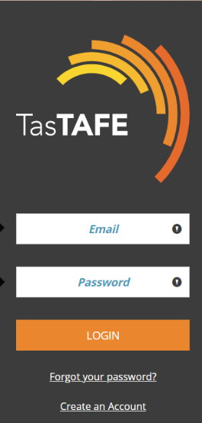

- If you have forgotten your password, click on Forgot your password? A password reset link will be emailed to you. Please note the link expires after 30 minutes. If you do not have access to your emails at the time we can assist.
- Once you have successfully logged in, make sure all your details are up to date – click on Your Personal Details.
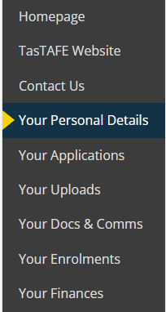
- If the course you are intending to apply for has entry requirements, and you already have copies of the evidence you can upload these in readiness – click on Your Uploads. This includes any other supporting documents such as Concession Card, Visa evidence, Credit Transfer evidence, etc.
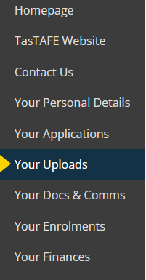
- Make sure you keep your login details handy. You will now be ready to go when applications open.

If you have not studied or applied with TasTAFE before:
You will need to create a Student Portal account. Before doing this, you will need to have your Unique Student Identifier (USI) number ready.
- If you don’t have a USI, don’t know what the number is, or need to update your details visit the USI website.
Here you can create a USI, check to see if you have a USI and find out what it is, or update your details if necessary. Please complete this process before creating your Student Portal account.

If you encounter any issues with applying, logging in or creating your TasTAFE Student Portal account, please see staff at Client Services on Campus or call 1300 655 307
- Go to the Student Portal and click on Create an Account using your personal email address. Please do not use a TasTAFE student email address to create an account. 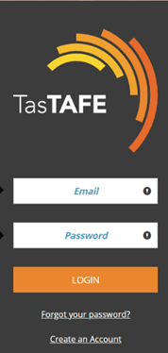
- Complete the details on the Creating a TasTAFE Student Portal Account page and click on Register at the bottom of the screen. You will not be able to do this until all required fields marked with an asterix have been completed, including your USI. Please note your USI needs to be valid and your details need to match those you originally created your USI number with.
- Once you register you will then need to complete Your Personal Details.
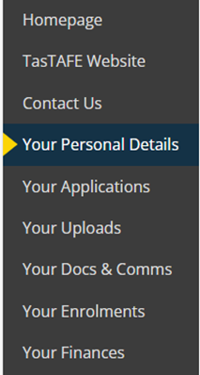
- If the course you are intending to apply for has entry requirements, and you already have copies of the evidence you can upload these in readiness – click on Your Uploads. This includes any other supporting documents such as Concession Card, Visa evidence, Credit Transfer evidence, etc.
- Make sure you keep your login details handy. You will now be ready to go when applications open.
If you encounter any issues with applying, logging to or creating your TasTAFE Student Portal account, please see staff at Client Services on Campus or call 1300 655 307

Applying to Study at TasTAFE

- Find your chosen course on the TasTAFE website and click
Apply Now
- If there is no Apply Now button on the course information page, the course is currently not taking applications. Submit an enquiry to receive information on when applications will be open.

- The Student Portal login page will open. Log in with your personal email address, read the instructions and then click CONTINUE APPLICATION at the bottom of the page.

- Follow the prompts and CONTINUE through each page.

- When you reach the evidence required page, please read the information at the top about what you may need to upload, full details are available on the course information page on the TasTAFE website.
Note: If you do not have the evidence required available to upload at the time of applying, please continue to submit your application. You can provide this evidence later, and you will be requested to do so before your application can be progressed.

- Select your evidence type and upload documents by clicking Choose Files. Click UPLOAD
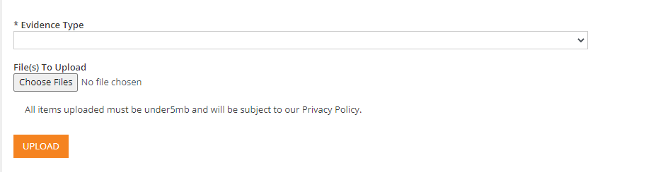
- Read the Privacy Notice and Declaration and Consent information and then click the I Agree tick box at the bottom of the page.

- Review the information you have entered and edit if required
- Click on SUBMIT APPLICATION
- You will receive communication from the Admissions team via email on the progress of your application, or if there is anything else we need from you. Please check your emails regularly. If you have any questions about the progress of your application please email Client Services or call on 1300 655 307
If you encounter any issues with applying, logging in or creating your TasTAFE Student Portal account, please see staff at Client Services on Campus or call 1300 655 307

