TasTAFE Accommodation – Making a Booking Online

Go to the TasTAFE Website – www.tastafe.tas.edu.au
On the top right hand side of the screen, click StudentConnect / Login
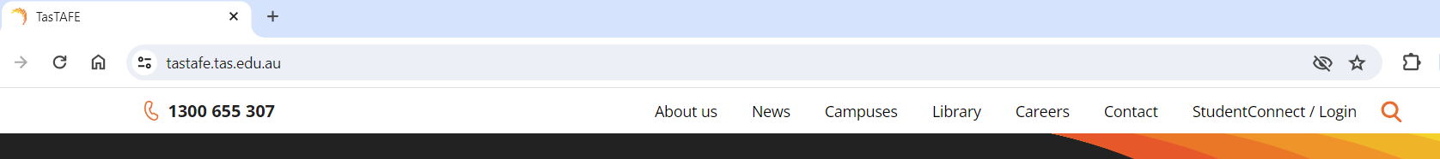
Click on Student Portal
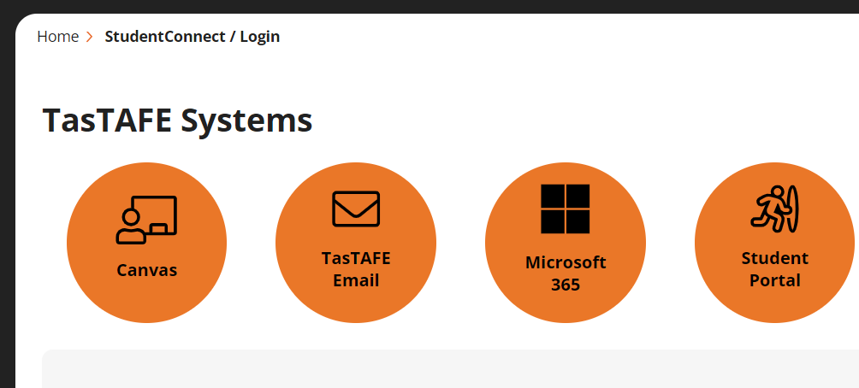
Enter your email address (this is the email address you put on your enrolment form)
- If you have used the portal previously and know your password, enter your password
or
- If you have never accessed the portal, click on Forgot your password
This will generate the reset password link to be sent to the same email address you entered on your enrolment form.
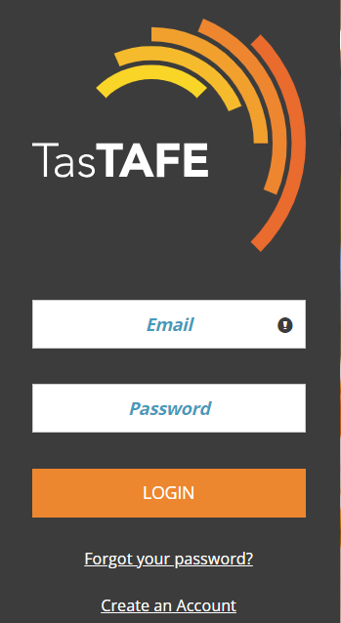

Once you have logged into the portal, select Student Accommodation
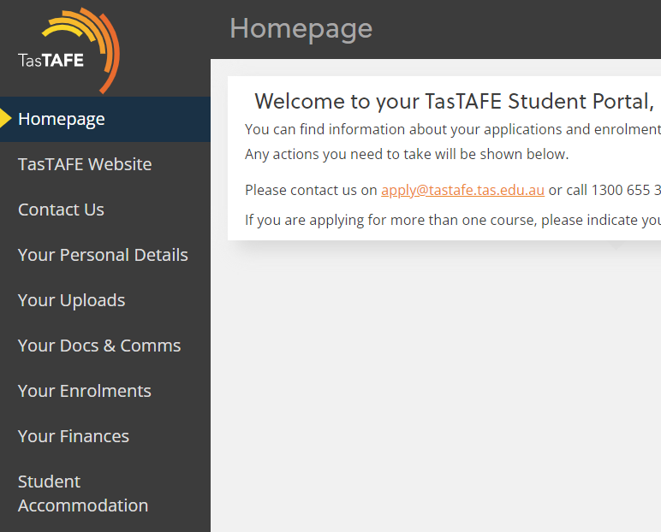

If you are under 18, you will be asked the following question:
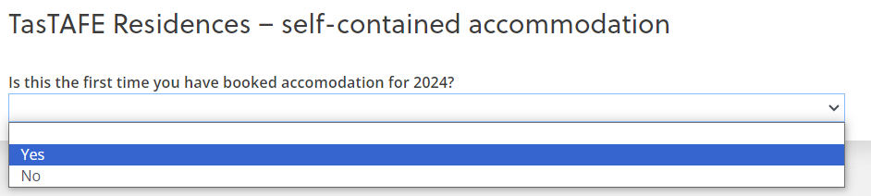
Select Yes or No
If it is your first time booking accommodation for 2024, you will receive the following message
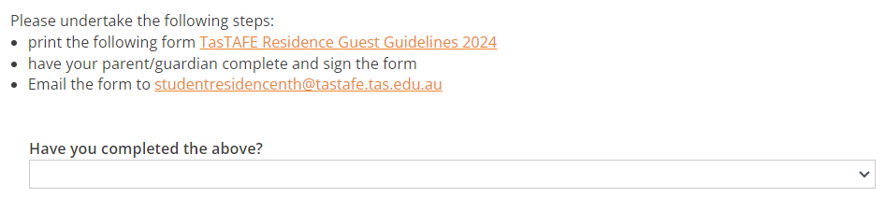
Once your form has been signed and emailed, select Yes from the drop down menu
You need to read and agree to the guidelines listed, see below:
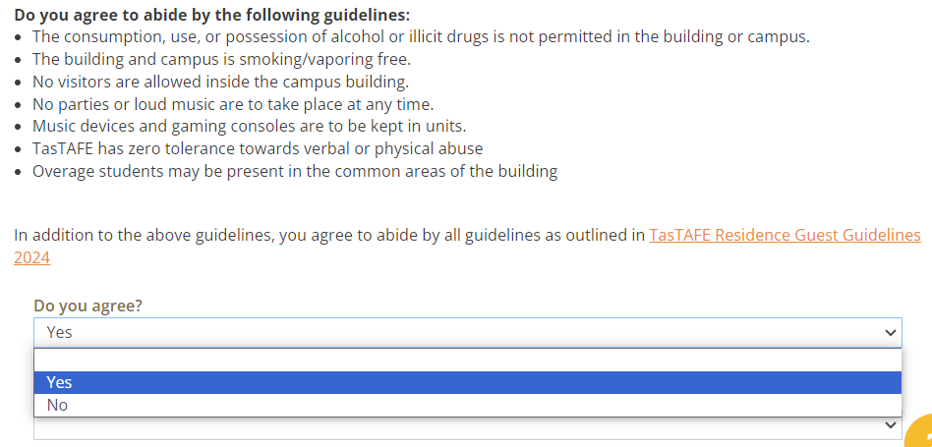
Select the campus you are booking accommodation for:

Click on the link. The link you are given is based on your age and gender on your enrolment form.
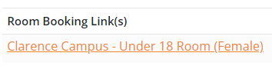
A dialogue box will appear at the top of your screen advising you are leaving the site.
Click on Leave
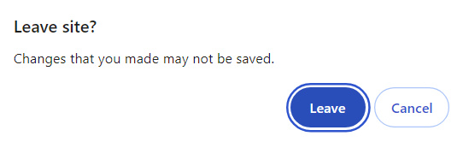

You will be redirected to the RMS Online website, this is where all TasTAFE accommodation bookings are made.
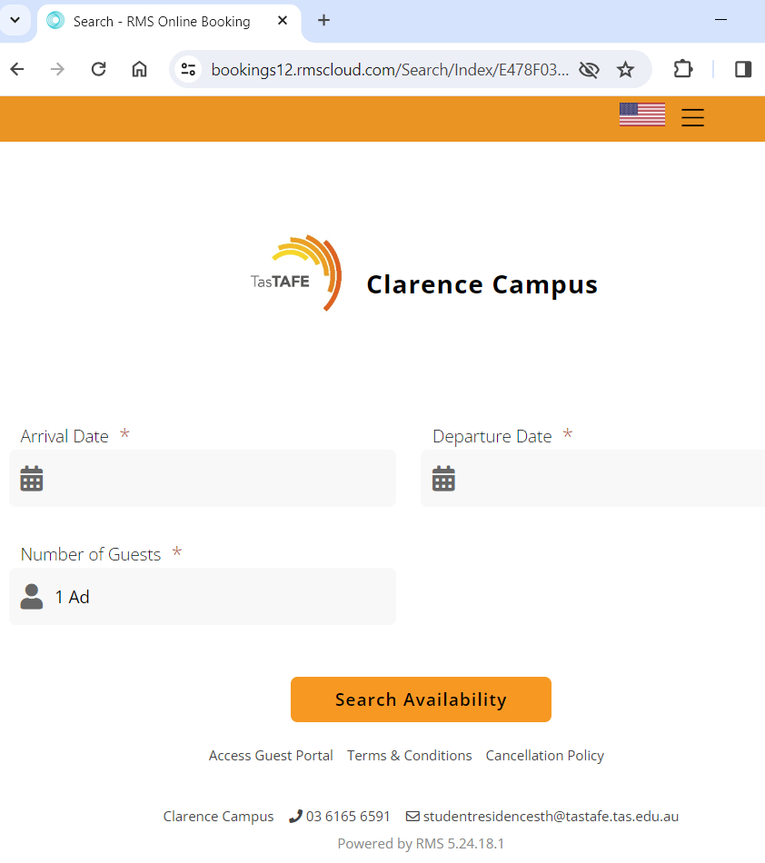

To select arrival date click on in the arrival field, this displays a calendar.
Ensure arrival is orange at the top of the calendar
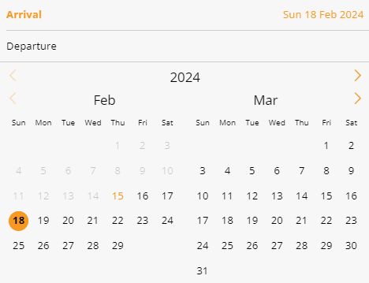
In the calendar click on Departure, then select the date you will depart the accommodation.
Note: accommodation is to be vacated by 9am on the day of departure.
Check Out is not available on Saturday and Sunday.

Check the dates are correct, the select Search Availability
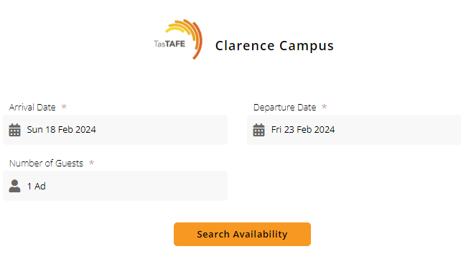
Choose Select Rate
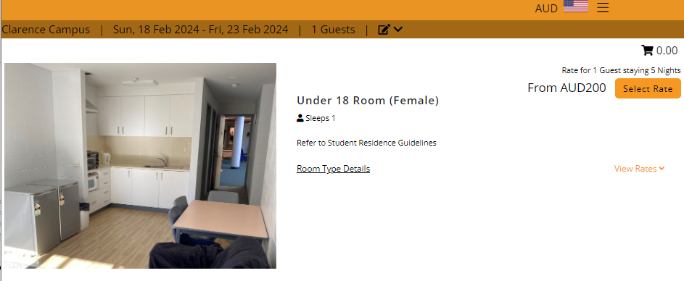
Select Continue
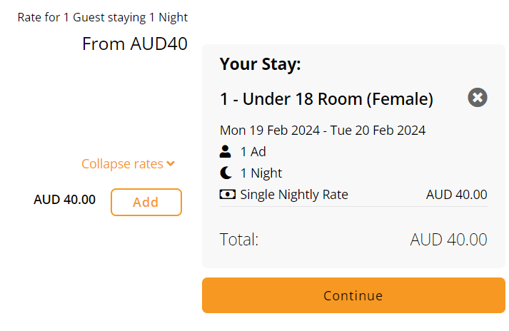
Doona and towels are not included unless you select them here, the charges are per night
NOTE: All beds have a mattress protector, bottom fitted sheet, pillow and pillow case.
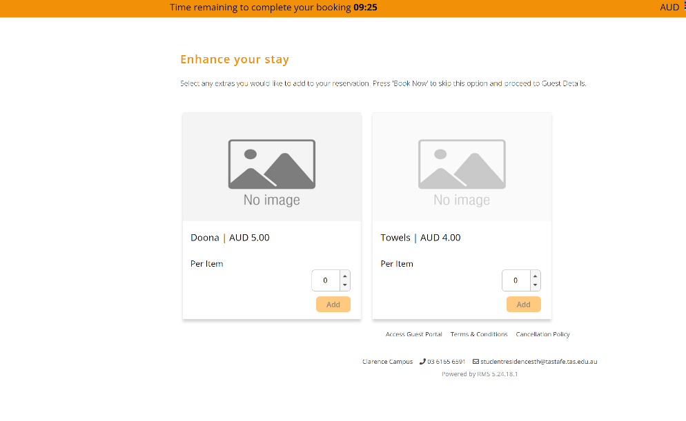
Enter Guest Details, all fields with an * must be completed
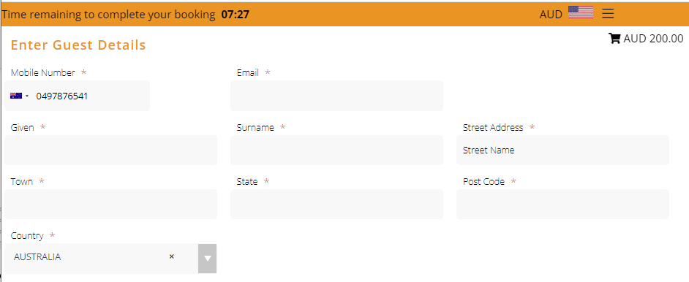
Click on Confirm
Note: Bookings must be paid for at the time of being made.
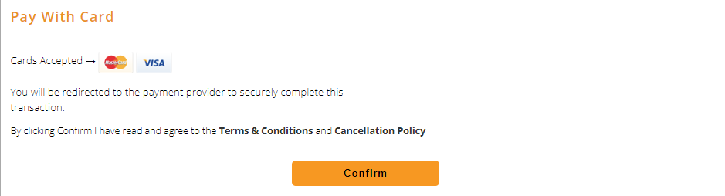
Enter your credit card details
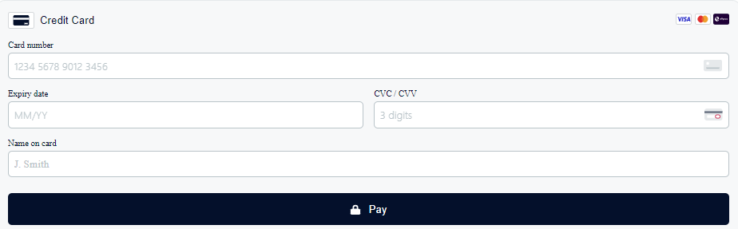

The next screen will be your booking confirmation
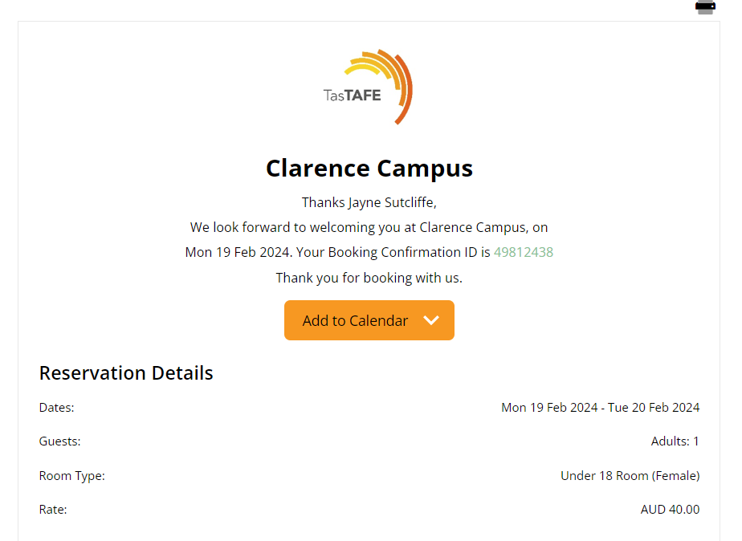
You will also receive an SMS confirmation
A SMS is sent 2 days prior to your booking asking you check in, this must be completed
At 3pm on your arrival day, you will receive a SMS asking you to check in, this must be completed to generate your access codes.

