



**TasTAFE   
bksb   
user guide**

# Basic Key Skills Builder (bksb)

## What is bksb?

bksb is an on-line assessment tool that is used to review your Literacy and Numeracy (English and Maths) skills, and is offered to students at TasTAFE undertaking most qualifications.

Upon completion, a level is given which is matched to the Australian Core Skills Framework (ACSF). This ACSF level is used to inform teaching staff how to better support you as a student, as well as to provide a benchmark for entry to specific courses.

## Before you complete bksb

You must complete the Initial Assessments for both English and Maths assessments individually and without help from others.

If you think you may need additional support, or you don’t have access to a computer, please contact Client Services on 1300 655 307 for assistance.

Please consider the following prior to commencement of your assessments:

* you will only be given one chance to do the assessment, but you can stop and continue the assessment in multiple sittings if needed
* when doing the two assessments (English and Maths), allow approximately 30-60 minutes for each assessment
* only complete the diagnostic assessment when asked by your teacher
* you may use a calculator for the Maths section if you wish
* it is recommended that you do the bksb assessments on a computer or tablet rather than a phone
* your login details will be set with your Learner ID (8-digit number) as your username, and your date of birth (in format DDMMYYYY) as your password
* it is recommended you look at the tutorial first as it goes through the different question types and how to answer the questions.

Some accessibility features are built into the bksb application and will work dependent upon your set up, but will not aid in providing you with answers to questions.

Specific accessibility features can be adjusted in the settings menu in the top left of your screen as you commence the assessment.

**Note:** The information you provide – including your results in bksb – is accessed only by TasTAFE staff and is used for processing applications and for staff to identify educational support needs.

The information gathered will be managed in accordance with the *Personal Information Protection Act 2004* which underpins TasTAFE’s Personal Information Protection Policy.

## Contact us

For assistance or support, please contact us via email at: [**bksb.support@tastafe.tas.edu.au**](mailto:bksb.support@tastafe.tas.edu.au).

# Student User Guide

## To complete the bksb English and Maths Assessments:

* go to [**https://tastafe.bksblive2.com.au/**](https://tastafe.bksblive2.com.au/)
* enter your login details, including your username and password
* your username is your Learner ID (8 digit number)
* your password is your date of birth (DDMMYYYY)
* then click the LOGIN button.

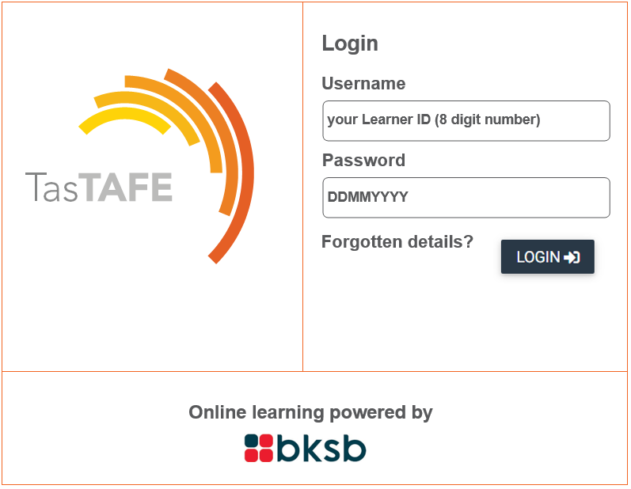

* on the BKSB home screen – click ‘continue’

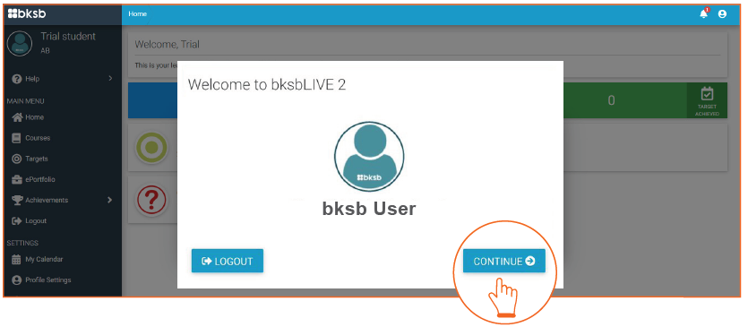

* read the terms and conditions, scroll down and click agree to continue

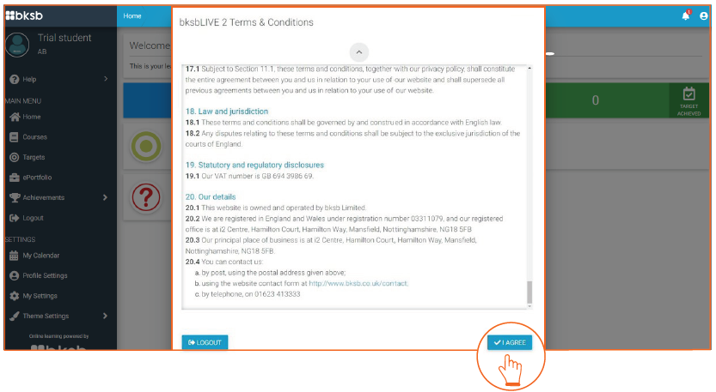

* you will be asked to change your password

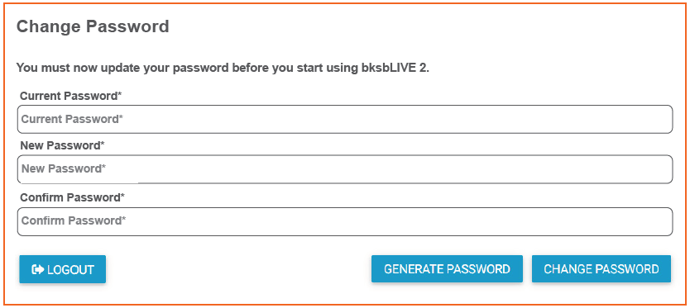

* it is recommended to start with the Tutorial first, then complete the English and Maths Initial Assessments

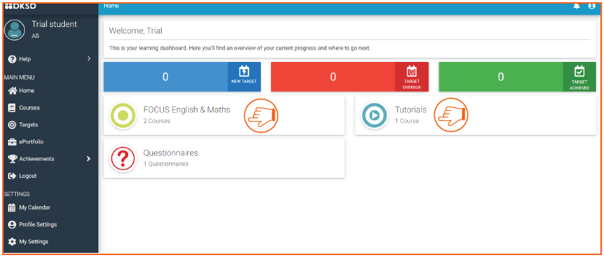

* once you have selected ‘FOCUS English & Maths’ you will need to take the Initial Assessment for English, and once completed, take the Initial Assessment for Maths. These assessments are shown on the one page, beside each other. Allow approximately 30-60 minutes for each assessment

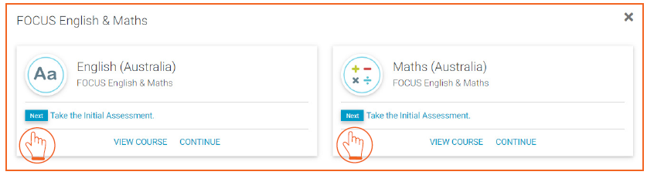

* after completion of each initial assessment you will be presented with a result from level 1-5, where 5 is the highest

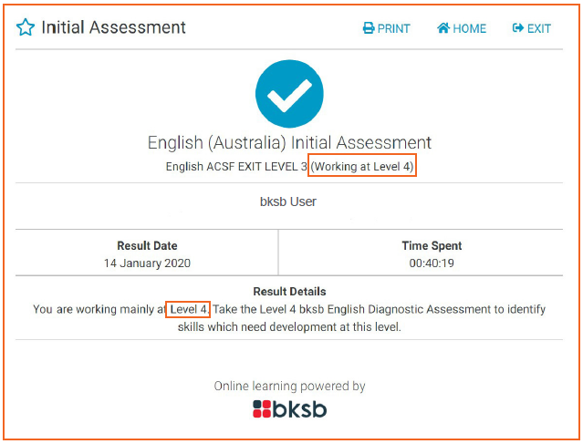

* after each Initial Assessment, you will be prompted to progress to the Diagnostic Assessment

Only complete the Diagnostic Assessment if you have been asked to complete it by a teacher or TasTAFE staff member.